Payment of Traffic Infringement Notices In LTA

Brief Introduction
Traffic Infringement Notice is issued to the offender when they commit any offence on the road under (Section 86 and Section 92 (1) of Land Transport Act 1998). The Authorised officer LTA /Police or Municipal under delegated powers are liable for the Traffic Infringement Notice issuance.
Payment of fixed penalty is received as specified below at any Land Transport office, all liability in respect of the offence will be discharged and no further action will be taken. However, if that fixed penalty is not so paid, you are hereby required to attend Magistrates Court to answer the charge set out in the Traffic Infringement Notice.

Checklist
- Original copy of TIN

Fees
- Fixed penalty as per offence committed

Process
- TIN issued to the offender
- TIN Payment to be done within 90 days from the date of booking as stated in the TIN
- Payment can be done at any nearest LTA Office/Post Office or through M-Paisa
- After the payment is done client does not require to appear before the Court as stated in the TIN.

Workflow Summary
- 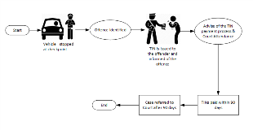

For more information, access https://www.lta.com.fj/enforcement/traffic-infringement-notices

