PROTO-POLYNESIAN ART? THE CLIFF PAINTINGS OF VATULELE, FIJI
RODERICK EWINS University of Tasmania
Vatulele is an island 13 kilometres long and varying from under two to about five kilometres wide, lying about 32 kilometres off the southern coast of Vitilevu. The name Vatulele means ‘sloping/slanting rock’ in Fijian (personal communication, Paul Geraghty, 13th Sept. 1993), and in fact the island does resemble an extremely low tilted platform, varying in height from a metre or so above sea-level on its eastern side to 30-metre cliffs at the highest point on the west coast, and it is visible from high vantage points on the mainland coast only on clear days. Its geological origin has been the subject of considerable conjecture. The fact that deep seas surround the island suggests that it originated as a submarine volcanic cone, which was levelled off by marine erosion, covered with a deposit of limestone to form a platform and then raised above sea-level by uplift (Ladd 1930, Coulson 1968:6, Rao 1984). Recent work (Nunn 1987) suggests that not one but successive sectional uplifts have resulted in the easterly slope which the earlier writers cited ascribed to tilting of the entire limestone mass.
The rock-paintings form an extended gallery of at least 95 images painted on the face of low, wave-cut limestone cliffs on the west coast of the island. 1 This is the only rock-painting site documented for Fiji, 2 although there have been 16 rock-engraving sites documented to date (a more detailed discusson later). The fact that the people of Vatulele know nothing of the origin of the paintings, have no legends or traditions regarding them, and do not attribute any particular significance to them, suggests their authorship by people distinct from the present inhabitants. 3 Judging from the degree of weathering and of limestone accretion over a number of the images, the paintings are apparently of considerable antiquity. Only very brief and incomplete information has been provided about the Vatulele site in the two short publications to date which deal with the paintings, the earlier by a geologist working briefly on the island (Paine 1929), the later by a pair of archaeologists from the Fiji Museum who visited the island (Palmer and Clunie 1970). The dilemmas relating to any attempts to deal with Pacific rock-art have been eloquently summarised elsewhere (Specht 1979:58-60), and in part explain the paucity of information about the Vatulele site.
- 24
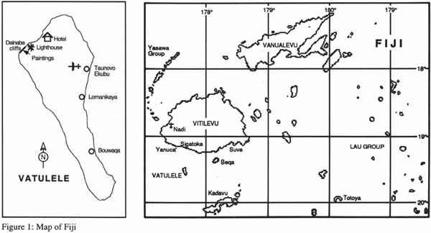
- 25
To provide myself with material for detailed analysis, every panel was photographed on five separate short visits to the site, through the period 1980-1993, using both black-and-white and colour slide film with two Nikon cameras. Photographs or details that proved to be unclear after one session were re-documented subsequently. Where necessary, telephoto lenses were used from a distance to achieve a more direct view of high images and minimise distortion. All photography (after the initial familiarisation visit) was done in the very early morning before the sun hit the cliff-face, and on two trips, polarising filters were used to further reduce glare. In the case of the black-and white photographs, on two trips light blue filters were used to enhance the red-brown images and help fade out the numerous grey water-stains. Both site photographs and various levels of detail photograph were taken. A few small on-site sketches were made of details that were particularly elusive. I unfortunately was unable to bring a ladder or other climbing equipment to the site to permit ‘touching distance’ examination of every image, or accurate measurement of sizes or distances between images. In that particular, therefore, this survey is incomplete, but I am confident that I have documented, as completely as it is possible to do, all of the images that are not thoroughly obscured by fading, veneering with calcite runs, or delamination of the rock-face.
This paper attempts a fuller and more accurate documentation of the paintings than has previously been made. The imagery of the paintings is compared with that of known Pacific art, both prehistoric and that in existence at the time of Western contact, to attempt some stylistic contextualisation. It is suggested here that there are a number of stylistic affinities between various of the Vatulele images and their counterparts in Polynesian art, and Proto-Polynesian and Polynesian presence in Fiji is discussed as providing possible authorship of the paintings.
Such an approach proposes the use of artistic evaluation/comparison in the debate about prehistory. I am mindful of Roger Green's comment (1979b: 14) that stylistic analysis is frequently regarded as ‘historically naïve and too subjective and lacking in methodological rigour to furnish useful hypotheses,’ though art historians would, of course, challenge such views. My purpose is not to pretend to any absolute proof, which under the circumstances is impossible, but I believe it can furnish useful clues in some areas where archaeological proof is at present lacking, and these in turn may suggest potentially fruitful directions in which to seek confirmation or refutation.
The north-west corner of Vatulele is the highest point of the island, ending in the seaward-facing cliff which reaches a height of over 30 metres. The cliff-face consists of extremely dense metamorphosed limestone (cule in- 26 Fijian), which is generally almost white, bright and reflective, but streaked with dark grey stains and chalky calcite runs. At the northern end of the cliffs, just south of the long white strand of Vetau Beach, 4 is a lighthouse, and the cliff-face extends southward as a sheer wall for several hundred metres after this. At the northern end the cliff bears two distinct wave-notches, the lower one just above the ground with its centre about 30 cm, below the present high-tide level, and another some 1.8 metres above this (measurements from Sugimura et al. 1984:157) which is particularly pronounced and has the appearance of a continuous ‘shelter’. Moving south, the lower notch becomes buried progressively deeper, first with rock debris and then with sand. There is a fainter notch some 2-3 metres higher than the higher of the two pronounced notches, and other indications of marine abrasion on the high cliff-face. These are less distinct and apparently of great age. They have more recently been surveyed by Patrick Nunn of USP (Nunn 1988b: 11, Fig.4). These notches are known to the people of Vatulele as calevu ni yalo — ‘paths of the spirits’. Above this the wall of the cliff is relatively flat and even, leaning outwards very slightly. The seashore immediately below the cliff is a gradually sloping smooth rock platform, exposed at low tide for perhaps 50
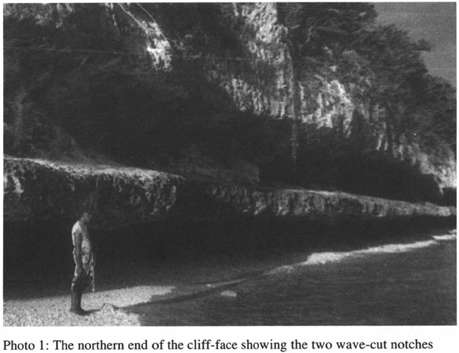
- 27
metres. It shows numerous fossils of shells, echinoderms, and jellyfish. There is some coral sand in hollows in the platform, and small boulders lie at the foot of the cliff where they have been cast up during storms.
The cliff continues exposed for a couple of hundred metres (the area being known as Dainaba), after which the foreshore curves out perhaps 50 metres from the cliff to form a headland. Here the rock platform is covered in a sufficiently deep sandy soil cover to support fairly dense scrub and some very large trees, including the once-sacred vesi (Intsia bijuga). Towards the southern end of this forested promontory, the cliff is perforated by two small interconnecting caves, the lower of which is fed by subterranean tidal channels. Similarly sourced is a long open-air pool slightly inland from the caves.In this and the cave-pool are found the unusual red-coloured prawns (Parhippolyte uveae, locally called urabuta) for which the island is famous (Derrick 1951:160, Choy 1987). The name of this area is Wavuimata, with the pools called after the prawns, Na Ura.
The gallery of paintings is on the cliff-face above the elevated wave-notch. It begins on the exposed cliff-face of Dainaba, north of the forested headland, and continues south for about 240 metres. It ends about 300 metres north of the red-prawn grotto. On a sunny day the entire cliff-face becomes
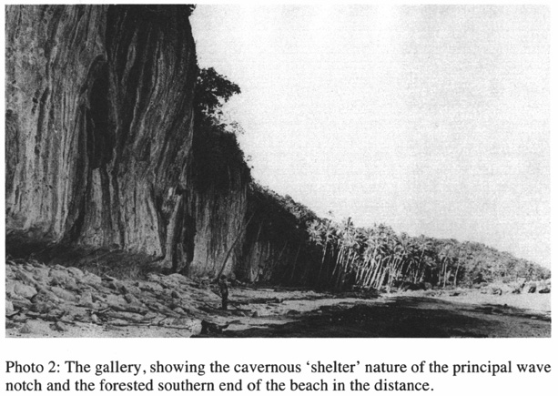
- 28
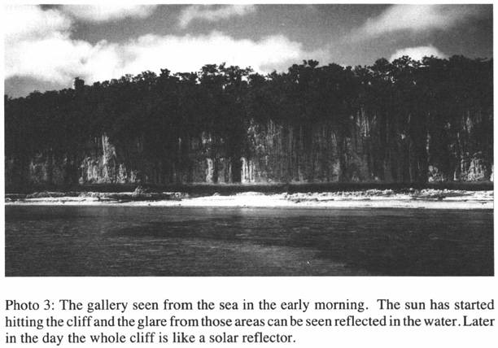
a glaring mirror, clearly visible from a substantial distance when approached from the west or north-west. This is important for two reasons: first, it functions almost like a beacon, and would certainly have attracted the attention of any eastward-bound seafarers who passed near; and second, the paintings can only be seen adequately very early in the morning, between about 6.30 and 9.00 in mid-winter and earlier in summer — once the sun hits the cliffs, the degree of glare means that all but the most obvious of the paintings become lost to view until late afternoon, and even then the yellow sun tends to obscure the fainter red-ochre-coloured images. This fact may explain, at least in part, why the earlier recorders (Paine 1929 and Palmer and Clunie 1970) missed most of the more northerly panels completely, and did not list all of the images on the three locations that they did see — Panels #1, #3 and #6.
The paintings (today called simply na volavola — a word connoting writing and similar mark-making) have every appearance of having been deliberately and carefully executed, with no pains being spared to ensure their permanence. The rusty red colour of the images contrasts markedly with the dark grey water-runs which naturally stain the cliff-face. The ‘paint’ used appears to be haematite or one of the other iron oxides, which readily and durably permeate limestone. Iron-bearing rocks and haematite ‘earth’- 29 are found on Vatulele and in the neighbouring area of Vitilevu. Where Vatulele's ubiquitous white limestone outcroppings emerge through areas of haematitic clay, they are typically stained rusty red to a substantial depth, in some cases 2 mm or more.
It seems likely that a paint was made by liquefying this haematitic clay or soaking nodules of haematite in salt water, with the resultant rusty liquid then used as paint. This is consistent with the nature of the images, all of which appear to have been either stencilled, imprinted, or painted but not drawn with solid drawing agents (see Specht 1979:60, citing L. Maynard's system of classifying rock-art). The stain apparently penetrates the rockface to a considerable depth, at least in some places. Paine (1929:151) remarked that a ‘rather too inquisitive’ visitor to the site had attempted to chip some of the images with a hammer, but the extreme hardness of the rock, and perhaps the depth of penetration of the staining, fortunately defied his efforts. There are chips in a number of images, which, while they look like intentional percussion bruises, are ascribed by the locals to hurricane damage, since fair-sized stones can be swept off the reef and hurled against the cliff-face. These seemed more noticeable following the 1983 hurricane than on my earlier visits to the site, though I had no way of quantifying this impression. However, in 1980, the southern four panels were well into the forest, whereas today, as a result of several storms and Hurricane Oscar in 1983, the trees and scrub which had offered concealment have gone, and all that remains in front of the gallery are some coconut trees. The forest proper does not now begin until the headland expands out, some 20 m beyond the end of the paintings. This contraction of the forest towards the headland appears to have been a recent process, as I have been told that formerly there were large trees, including vesi, right along the foreshore in front of the gallery, where today there is mostly exposed reef platform with no soil or trees. 5 The existence of large vesi trees is significant as they are very slow growing trees, and those of the size described would have been many hundreds of years old. Thus, it may be assumed that the gallery received protection from this forest for hundreds of years. The loss occurred when Hurricane Bebe in October 1972 brought high seas which eroded very large sections of Vatulele's shoreline. The resulting exposure no doubt has implications for the effect of the elements on the paintings. The worst damage is that which results from delamination, a process in which small sections of limestone shear off the cliff-face in thin sheets (5-10 mm thick). An examination of the sandy beach at the foot of the cliff reveals very little debris of this sort, but there is evidence that the process does occur. At some time in the past a ‘head’ image appears to have been lost in a disc-shaped delamination, above which there are the remains of a painted ‘headdress’ fringe. It is impossible to say whether- 30 this was caused by natural delamination or human action, or when it occurred. Between June 1989 and June 1993,I did document that the same panel has suffered a further delamination in one small painted section, possibly as a result of the hurricanes John and Kina in December 1992. It is, thus, entirely possible that delamination has caused the loss of images over the course of time since the gallery was painted, and the type and range of those in existence today may not truly reflect the original situation. Normal wind/rain/sand weathering is also gradually occurring, despite the hardness of the rock and the fact that the cliff is on what is normally the leeward side of the island. Despite the fact that the stain has penetrated to a significant depth, the amount of weathering that can be sustained is finite, and some images have become quite faint or even undecipherable.
Notwithstanding the above observations, the evidence is that the paintings are remarkably durable and that the process of fading and/or weathering away is extremely slow. In places a veneer of very hard semitranslucent white calcite, caused by the dissolving and re-accretion of the cliff surface by water trickling down it, has partially covered paintings. Given the low to moderate rainfall Vatulele has, such a process must be very slow, and indicates considerable age for the paintings. 6 Similarly, some obliteration is due to stain-runs from the soil and vegetation above the cliff.
The gallery has been regularly visited, by both indigenous and foreign tourists, over a long period and quite intensively for at least three decades. Since 1990 the nearby Vatulele Island Resort has been conducting regular visits. In the absence of any form of physical barriers, experience at other sites around the world makes it clear that particularly the lower paintings within easy reach are at risk of manual abrasion, graffiti-overlay, or physical destruction. 7
The panels
While the images are fairly randomly positioned along the wall, there are gaps between rough groupings which are here called ‘panels’. There are nine of these. There is little, if any,apparent connection between adjacent images or groups of images. The following is a description of the images that it is still possible to identify, listed from north to south. All distances are very approximate, a combination of measuring where feasible and pacing out over irregular terrain, and are intended to give some relativity rather than pretending to mathematical accuracy. Similarly, heights given are estimations above present ground-level — AGL. No attempt has been made to list the numerous rather amorphous and quite undecipherable red marks, nor the images which are so faded as to be undecipherable.
Ninety percent of the Vatulele images are figurative, including 53 hands- 31 stencilled in negative or printed/painted in positive — 63% of the figurative images,or 56% of the whole gallery. This contrasts with the rock-engravings found in a number of sites throughout the group (16 documented to date). 8 Some of these consist of abstract forms in jumbled juxtaposition to one another (Land 1919, Vogan 1937, Snow 1953, Parke 1961, Palmer and Clunie 1970), others consist of concentric circles and/or spirals (Phillipps 1951, Hill 1959, Palmer and Clunie 1970). Even the 11 clearly abstract symbols on the Vatulele site are different from those of the Fiji engravings, and are discrete and separated forms as compared with the often connected ‘jumbled script’ nature of the abstract engravings. Figurative (anthropomorphic or zoomorphic) engravings have been described (St. Johnston 1883: 256; Parry and Watling 1988) but these also are unlike any of the figurative elements on the Vatulele cliff-face. Only one zoomorph of a turtle recorded for Nananu-i-Ra island (Hiener, n.d.), finds an equivalent among the Vatulele forms.
Panel #1 This panel is approximately 100 m south of the lighthouse. It consists of a group of four images, the top of which are approximately 4.5 m above the rock platform on which one can stand.
- (a) Negative left hand c. 4.5 m AGL
- (b) Obscured bird form c. 3 m AGL
- (c) Jungle-fowl wing or male's tailfeathers c. 3.2 m AGL
- (d) Partial drawing of male jungle-fowl facing north c. 3.2 m AGL
The two images of jungle-fowl face each other, and are approximately 1.8 m from the northern tip of one to the southern tip of the other +40 m.
Panel #2 Two groups of several images, separated by about 2.5m. The principal elements of each group are about 4 m AGL, while the hand (c) is a further metre above.
- (a) Three-pointed figure, apparently negative leaf (species unknown)
- +0.5 m (b) Standing human figure
- (c) Left hand in negative, c. 1 m directly above (b)
- + 2.5 m (d) Small symbol — hollow square with two extended sides
- (e) Immediately above (f), a clear black form, apparently a headdress of the same kind as #5(g), with a faint outline, apparently of a face, below it.
- (f) Dancing human figure (rather faint) stylistically very similar to 2(b)
- + 1 m (g) Undecipherable form, obscured by calcite ‘runs’
- (h) Also obscure form, possibly a bird, right and above (g)
- +18 m.
- 32
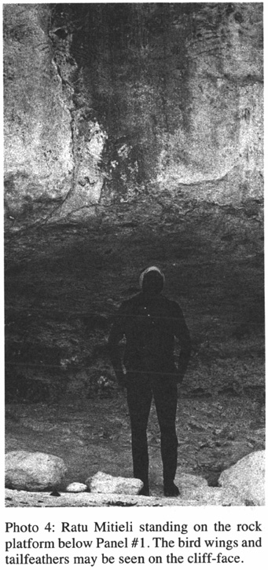
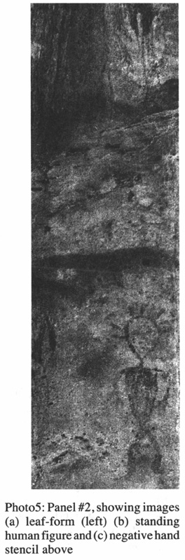
- 33
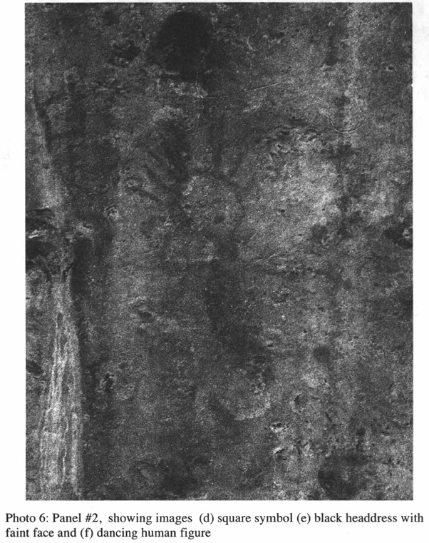
Panel #3 A large gallery, with a great range of images.
- (a) Double-lateen-sail canoe facing north, with star over bow
- (b) White-tailed Tropic Bird facing north. Tail and legs clear, body and head obscured c. 4.5 m AGL
- (c) Human face with face-paint c. 3.5 m AGL
- 34
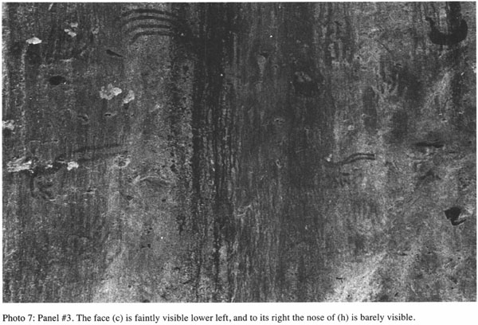
- 35
- + 1 m (d) Jungle-fowl cock (complete) facing south
- + 1 m (e) Jungle-fowl cock (tail and part of body) facing north c. 5 m AGL
- (f) One left hand, two right hands (negative)
- (g) Smaller but very similar version of (b)
- (h) Very faint human face, directly below (g)
- + 1 m (i) Jungle-fowl hen
- (j) Very faint human face, to right (south). This appears to be a variant form (possibly incomplete) of the major faces at Panel #6(m). It lacks headdress or facial marking, but is otherwise very similar stylistically.
- +25 m.
Panel #4 Note: Just before Panel #4, there are a few lines which may once have formed an image, now obliterated. Panel #4 consists of a pair of images less than a metre apart, both about 4 m above —
- (a) Partial figure-part of the rock-face has flaked away taking the left (north) side of the face with it. The torso is basically shield-shaped, with one arm (south) and two-fingered hand
- (b) Right hand, negative
- +27 m
Panel #5
- (a) A group of four hands in negative, very high up the cliff-face, c. 6.3 m AGL
- (b) Right hand, negative c. 4.5 m AGL, below (a) Then, at intervals, several further paintings, all between 3.6 m — 3.8 m AGL.
- + 11 m (c) Right hand, negative
- + 2.5 m (d) Small black dancing figure, highly stylised
- + 0.5 m (e) Right hand, positive
- + 4 m (f) Left hand, negative, over negative leaf form
- (g) Very faint form which appears to be a head with a clear black ‘cap’.
- + 25 m
Panel #6 This is the principal gallery, densely figured with an extended group of more or less continuous imagery, including a number of children's (?) or women's (?) hands, measuring less than 14 cm from heel to fingertip, and the most elegant and well-preserved human faces, as well as a number of abstract symbols.
- (a) Two right hands of children (?), negative, c. 3.6 m AGL.
- + 1 m (b) Right hand of child (?), negative, c. 2.6 m AGL
- + 2 m (c) Two partial children's hands, partially overlapping
- + 4 m (d) Symbol, possibly a bow and 3-pronged fish/bird arrow, c.
- 36
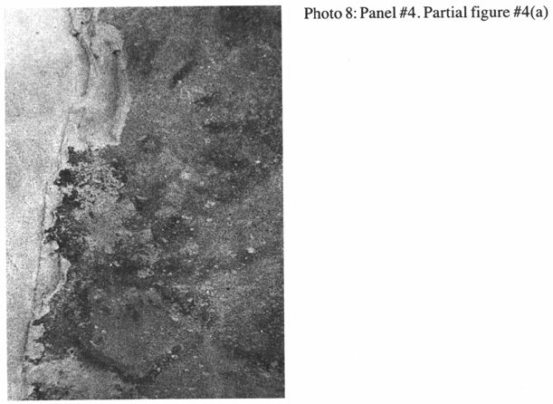
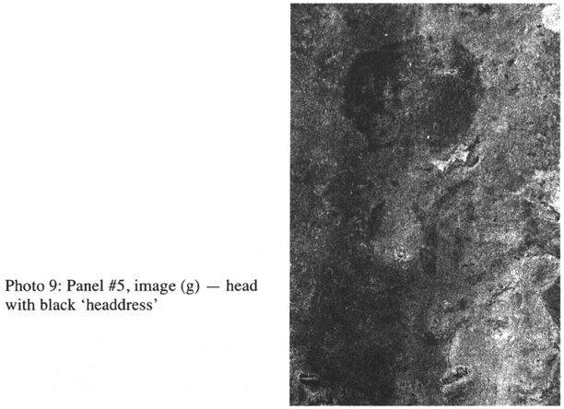
- 37
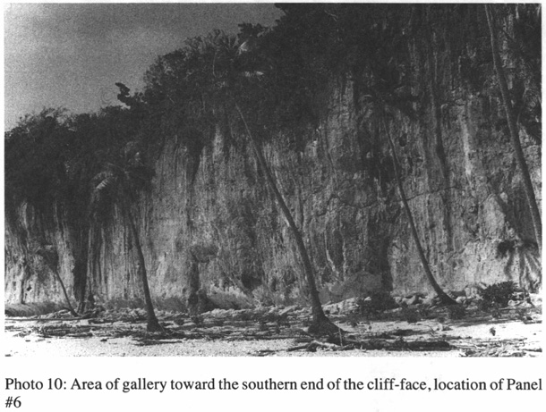
- 4.3 m AGL. This is in close conjunction with a dark shape which is undecipherable.
- (e) Sun/flying eagle, c. 0.5 m below (d)
- +0.5 m (f) Symbol — roughly circular (c. 40 cm diam.) with inward-pointing lines c. 4 m AGL
- + 1 m (g) 3 left hands, top one c. 5 m AGL.
- + 3 m (h) Child's (?) left hand, negative.
- +0.5 m(i) Right hand and forearm, negative, c. 4 m AGL
- +0.5 m (j) 2 negative left hands and one left hand, c. 3.5 m AGL, immediately above a right hand inside a leaf stencil
- + 0.5 m A group of images (k-o) within a 1 m x 1 m area
- (k) 4 right hands (negative) directly above 3 right hands in positive
- (l) Breadfruit leaf
- (m) 3 faces, stylistically similar, two clear, one obscured
- (n) Sea creatures situated inside the group (m) — the largest (n)(i) is possibly a seal, and (n)(ii) is a vertical row of three swimming turtles.
- (o) Left hand, negative stencil, and symbol, regular shield-shape divided cruciformly
- 38
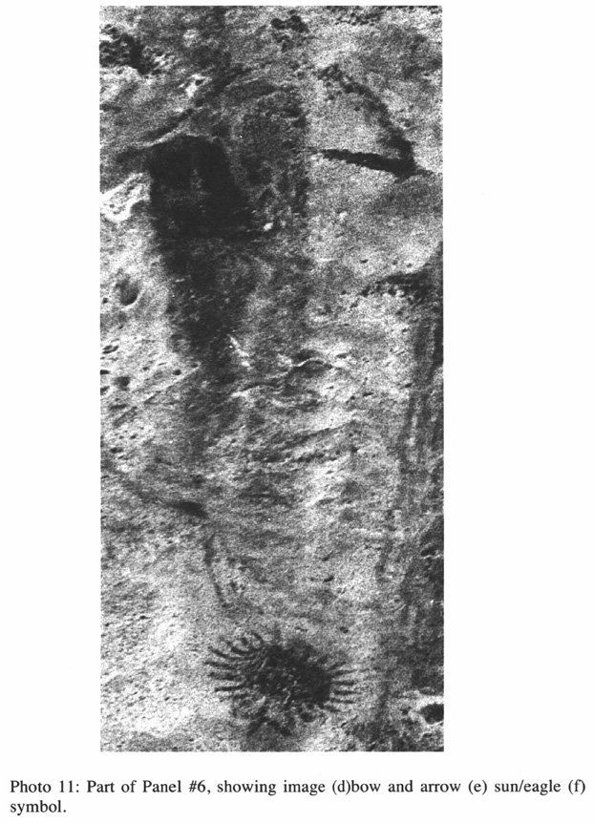
- 39
- +2 m (p) Symbol, irregular shield-shaped, divided cruciformly, 0.5 m lower than (o)
- (q) 2 left hands (negative).
- +2 m (r) Symbol, ovoid but difficult to read, possibly a face
- (s) 2 hands; Top arc of an unidentified fringed form, perhaps a head or sun image, the rest of which has flaked off
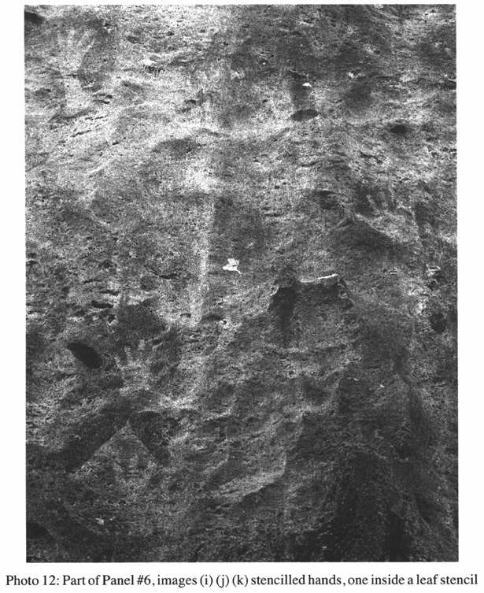
- 40
- +1 m (t) Left hand (negative)
- (u) Symbol, small rectangle with diagonal lines
- (v) 2 symbols, (i) above (ii), touching on one corner and possibly forming a single whole: (i) an incomplete quadrangle bearing the appearance of a map or plan (ii) a square with roughly diagonal division. Approximately 3 m AGL.
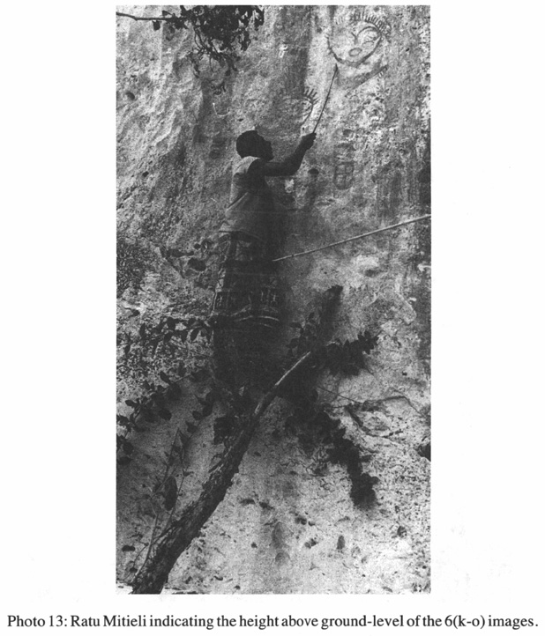
- 41
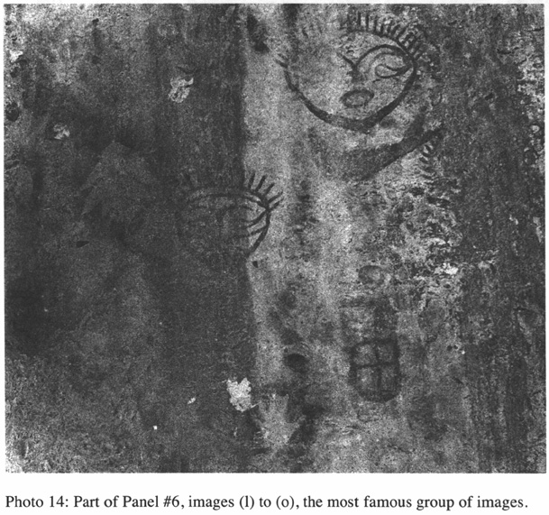
- (w) Bird, possibly a seagull. This black image seems to have been painted over previous faded images, undecipherable but bearing traces of radiating lines such as occur on the headdresses of the faces and dancing figures. c. 3.5 m AGL
- +3 m (x) Large combination face/symbol. c. 3.5 m AGL
- +1 m (y) Immediately above (v), a dark, vertical fish — possibly a shark. 3.75 m AGL
- +3 m (z) 3 right hands (negative) c. 4.5 m AGL.
- +25 m
Panel #7
- (a) Two hands in negative, left and right, with the thumb and index fingers touching, c. 3 m AGL
- (b) 3 hands in negative
- + 18 m
- 42
Panel #8
- (a) Two right hands in negative c. 4.5 m AGL
- +1 m (b) Four right hands and one left hand in negative c. 4.5 m AGL
- +1 m (c) One right hand, slightly to the left (north) of 2 left hands, all in negative c. 6 m AGL
- (d) One left hand and one right hand, negative, c. 7.5 m AGL
- +10 m
Panel #9 A solitary right hand in negative, c. 2.5 m AGL
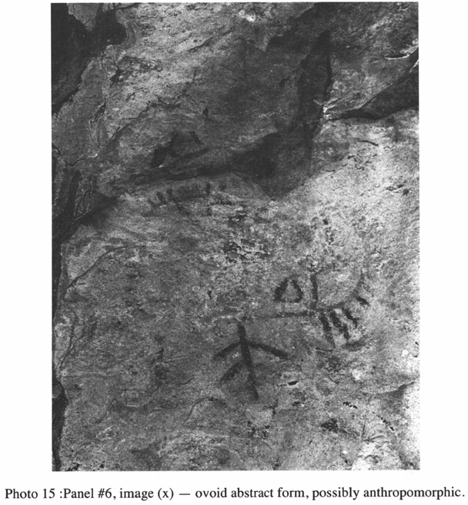
- 43
The paintings end about 300 metres north of the red-prawn pool, having extended for approximately 240 metres.
The Images
The following drawings and remarks detail the principal image types, though not all of the individual pictures (for example, no attempt has been made to illustrate all of nearly 60 stencilled hands.) The illustrations are drawn freehand by the author, by reference to a number of separate photographs in black and white and colour, sometimes based on scanned photographs, but not to scale relative to one another.
1. The human figures.
Three full figures exist, two stylistically closely related red figures at Panel #2, and one small dark brown-black one at Panel #4. All three appear to be characteristically Polynesian both in stance and in form, with dynamic postures which appear to represent dancing. Certain similarities exist between these figures and those carved on Tongan clubs (e.g. Barrow 1972:73-75). The small wooden and ivory figures for which the Ha'apai group of Tonga were renowned (Barrow 1972: cover, frontispiece, 65-71), while clearly deriving from the same tradition as the club-carvings, are more static and thick-bodied due to the different medium, and are thus less similar in
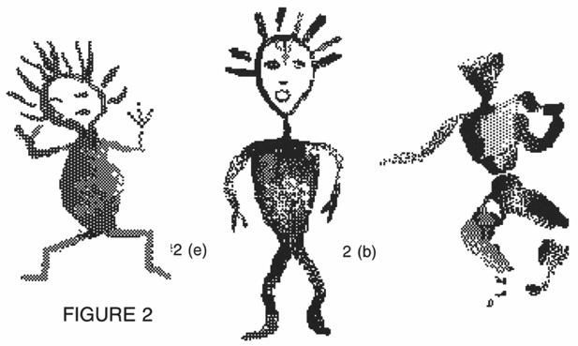FIGURE 2
- 44
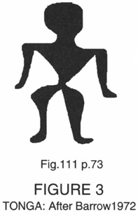FIGURE 3 TONGA: After Barrow 1972
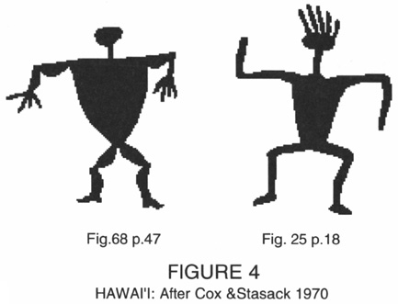FIGURE 4 HAWAI'I: After Cox & Stasack 1970
appearance to the Vatulele figures than are the club-carvings. 9 There are even some features shared with figures from the archaic period of New Zealand (Barrow 1972:49). The strongest similarities, however, are with some of the petroglyphs found in Hawai'i, described by Cox and Stasack (1977), making allowance for the change of medium from painting to engraving.
One in particular (p.18, Fig.25) described as ‘Figure with headcrest’, suggests that the fringes around the heads of the two Panel #2 paintings very probably also represent feather headdresses, 10 which were common throughout Polynesia (Barrow 1972:78-9,92-3,123), though by the time of European contact were less so in Fiji. There, although headdresses were not unknown, feathers were more commonly stuck into the hair singly (Ewins 1982:40) and ornate coiffure tended to take their place, with fine bark-cloth ‘turbans’ (more properly, head-scarves) serving both as signs of rank and to keep the coiffure intact (Williams 1858:25,41; De Ricci 1875:17).
In analysing the forms of the numerous human petroglyph representations in Hawai'i, Cox and Stasack refer to ‘male figures…of the triangular body, muscled type’ (p.47, Fig.67). The illustration resembles the body type in the two Vatulele figures 2(b) and 5(d). If one assumes a similar sex differentiation was intended here, this suggests that figure #2(e), different in both body shape and posture, was female. It is remarkably similar in form and posture to a figure in a petroglyph at Canterbury, New Zealand (Bellwood 1979:394, Fig.13.1f) 11 The very small figure #5(d) is more naturalistic in its overall proportions than are the two figures 2(b) and 2(e), is darker and has a solid
- 45
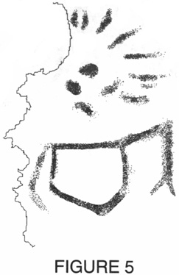FIGURE 5
head without fringe. It shares the triangulate torso convention of 2(b) and other Polynesian figures.
There is one partial ‘figure’ — 4(a) — that is very dissimilar to those illustrated above, and initially hard to recognise as a figure. It can be read as two separate images, a head and an abstract ‘shield’ symbol, with neither image easy to read as they are very faint. The fragmented ‘head’ image has lost its left (north) side due to delamination of the rock-surface. Despite its larger-than-life size, when compared with the other faces it is a mere ‘jotting’, with nothing more than headdress, eyes, nose and mouth being indicated in the briefest fashion. The ‘abstract symbol’ is, in fact, a shield-shaped torso, and possesses a left arm with a two-fingered hand, and a very faint right arm also. Its location immediately below the face connects them irresistibly. The shape of the torso provides an interesting stylistic connection to the abstract shield forms which occur elsewhere.
2. Human faces.
The most remarkable of these (2 clear, 1 obscure) are at the very large Panel #6 — #6(m) — and were seen and commented on by both Paine (1929) and Palmer and Clunie (1970). Another image some six metres south at the same panel, #6(v), is quite extraordinary, being a large abstract symbol with what look like human features (eyes, nose, mouth) incorporated into it. It is illustrated with the Abstract Symbols (Fig. 12). There are three very faint
- 46
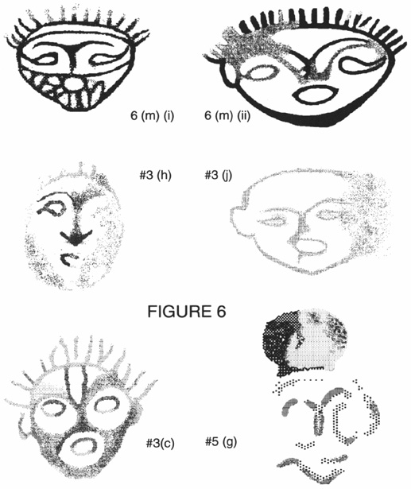FIGURE 6
faces at Panel #3, which show clear stylistic affinities with the 6(m) faces. 3(j) is very faint and almost undecipherable, but is the closest in form to the 6(m) faces. The northernmost, 3(c), appears to represent a person wearing face-paint. The other, 3(h), is extremely faint and different again stylistically. One other image, which is unique, occurs at Panel #5. Finally, as mentioned in the earlier discussion of damage to the gallery, there is clear evidence that a head has been lost from Panel #3 — a plate of rock has delaminated or been removed from the rock-face, leaving the tips of a ‘head-crest’ around its top margin. It was possible to measure only the faces at #6(m), which measure 38 cm x 38 cm and 45 cm (H) x 53 cm (W) respectively — substantially over life-size. The other heads appear also to be over life-size, and #5(g) is substantially so.
- 47
Where the heads bear fringes, these are notably shorter, more dense and regular than those of the full figures. There are no such lines on the most closely related head, 3(j). They may merely represent hair, or may still represent a form of headdress. The band which runs across the forehead of the smaller face #6(m)(i), above the eyebrows, looks exactly right as a headband. This could presumably be worn alone, but could also be the headband of a feather headdress like those of Samoa, the Cook Islands and Tahiti, all of which had wide bands which came some distance down the forehead (Barrow 1972:78-9,92-3,123).
The lighter lines echoing the brow-ridge/nose on the #6(m)(ii) face are also an interesting stylisation, which may derive from the artist's having been more accustomed to functioning as a sculptor (possibly in wood), and employing stylisations that related to that medium (see Fig 14). Certainly, the lines serve that purpose well, and the very smooth graceful merging of them is very characteristic of the sculptor's aesthetic. The marks across the 6(m)(i) face below the nose, although partially obscured by both staining and veneering, are formed into a mosaic pattern, and may represent a beard, particularly given the projection at the chin.
Head #3(c), while also bearing a headdress and an oval mouth, is in every other respect stylistically totally different from the 6(m) faces. The strong marking almost certainly represents a type of face decoration — painting or tattooing. It is the same overall shape as, but more finished than, the image only a couple of metres to its south [3(i)], but the latter looks like an incomplete drawing.
#5(g) is extremely abbreviated, and is barely recognisable as a face at all. The only care taken has been with the carefully painted dark form which is evidently head-gear, either a coiffure or a ‘turban’ of smoke-stained barkcloth (Ewins 1982:10). The latter likelihood is supported by the very strong
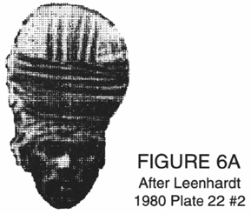FIGURE 6A After Leenhardt 1980 Plate 22 #2
- 48
similarity of shape between this drawing and the ‘turbans’ of New Caledonia worn into the postcontact era (Leenhardt 1980, Plate 22 No.2). This reading would raise the point of the common ancestry of Fiji and New Caledonia. 12 An enigma posed by this image is that the very dark colour and clarity of the turban clearly places it with what I regard as a later stylistic period of images in the gallery, 13 but the marks I have interpreted as a face beneath it are light-coloured (though stylistically quite unrelated to the other, early-period,faces).
3. Hands.
These are the most numerous of all the images on the cliff-face, approximately 50 of them, and they occur in every panel except #1. All are negative ‘stencil’ images except for four positive hands, one at #5(e) and a group of three at #6(k). On at least one occasion, the forearm has been included in the stencil, #6(i). In the case of #6(j)(i), a hand has been stencilled in negative in the centre of another negative image, apparently of a breadfruit leaf. Left
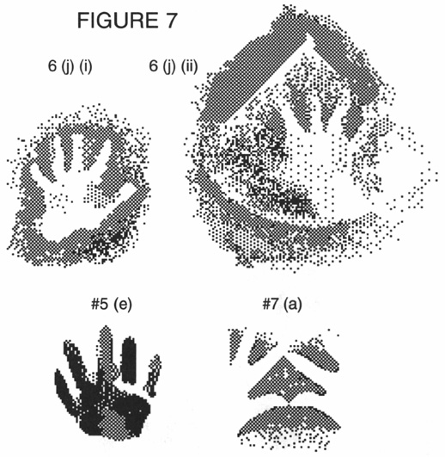FIGURE 7
- 49
and right hands occur in very similar numbers overall, and there are two instances of ‘paired’ hands, 6(c) and 7(a). In some cases, the outer edges of the ‘surrounds’ in the negative images are very close to the hands, which could suggest that hands were painted around rather than having paint sprayed around the hand by mouth, as has apparently been done in other examples here. The positive hand #5(e) seems to be a hand-print, from the varying ‘pressure points’ of light and dark, while the group of three positive hands #6(k) appear to be paintings, not imprints. This fact, together with their dark colour, suggest that these positive prints are of a later period than the negative ‘sprayed-stencil’ prints. 14
4. Birds.
These occur as whole birds, and as individual wings or tails. It is relatively easy to recognise the several male jungle-fowls, Gallus gallus or manu hegwa. The jungle-fowl was introduced to Fiji at an early period of settlement (Clunie 1984:30), probably by people of the Lapita Culture (Gibbons 1985:116), and is still widespread on Vatulele (Cranstone 1983:7). 15 The single jungle-fowl hen depicted in the gallery, however [#3(i)], has been described by Palmer and Clunie (1970:11) as a bush pigeon or dove, which it does resemble except for the tail, which resembles that of a jungle-fowl hen (somewhat squarer than the tapered tail of the European domestic hen), and not of a pigeon, which has a tapering tail in a line with its body. The creature #3(b) was suggested by Palmer and Clunie (p. 11) to be either an iguana with a double tail or a rail, a land bird found on the island. Both suggestions are unsatisfactory; the former seems an improbable subject, and the latter difficult to understand, since the rail has a short compact tail (Clunie 1984:31-32). I believe that they represent the White-tailed Tropic Bird (Phaethon lepturus, in Fijian lawedua), a seabird with two graceful long white tailfeathers that has long been both a powerful good omen throughout Fiji and a source of tailfeathers for chiefs' head decoration in Vatulele and elsewhere in Fiji. Lawedua nesting-sites are very common in crevices of the rocks on the cliff-face and grottoes surrounding the painting site.
Other images not previously recorded are:
- • The wings/tails at Panel #1
- • A small black well-preserved drawing,#6(e). It may be read as either a sun with a cruciform symbol below it, or as a bird in flight. As a bird, from its general form and ‘fingered’ wing-tip feathers, it would almost certainly be the Fiji Goshawk or sea-eagle (Accipiter rufitorques, in Fijian reba). This is common on Vatulele, one of its habitats being on the cliff-top above the gallery. The possibility of it representing both a sun and an eagle in a duality should not be ruled out.
- 50
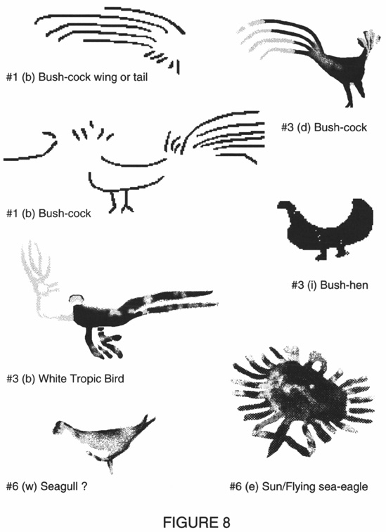FIGURE 8
- • The bird here tentatively identified as a seagull, #6(w)
The jungle-fowl, White-tailed Tropic Bird, sea-eagle and of course seagulls are still endemic on the island, and it is reasonable to assume they were present there at the time of painting.
- 51
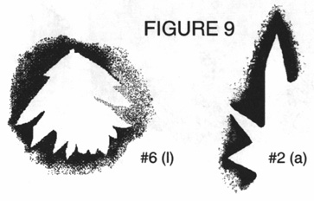FIGURE 9
5. Leaves.
One leaf form in negative, Panel #6(1), is definitely a breadfruit leaf. As with the negative hands, the size and shape of this indicate that an actual leaf was used as a stencil, and painted around. What is apparently another and larger negative-stencilled breadfruit leaf, #6(j)(i), has a hand in the centre of it, also stencilled in negative. Another stencilled leaf occurs at #2(a). It is less easily identified, but may be from the fan-palm (Pritchardia pacifica).
6. Sea-creatures.
There are several sea-creatures depicted at Panel #6. The first group #6(n), are immediately below the clearest human face in the gallery, #6(m)(ii). The image #6(n)(i) could be either a seal or a whale. Although seals are unusual visitors to these warm waters, they are not unknown. A few years ago, a seal turned up on the beach at Korolevu, on the coast of Vitilevu directly opposite Vatulele, and was photographed by tourists before it disappeared into the sea. 16 Whales are not uncommon visitors to Fijian waters, and sperm whales have long been a source of the tabua ivory teeth so essential to Fijian ceremony (Clunie 1986:160-; Ewins 1982:89, 97). Derrick (1951:160) describes their migration from the Antarctic to Fijian waters from June to August for the purpose of breeding. They were, right up to the mid-19th century, sufficiently plentiful to make Fiji one of the hunting-grounds for whalers from Australian and American ports (Ewins 1982:1, 89, 100; Langdon 1979:47-50). Remarkably similar stylistically, but clearly representing a dolphin, is a painting at Wamerei Island, Irian Jaya, from the early period illustrations (Röder 1959:115, No.5)
The second image #6(n)(ii), is a row of faint negative forms, at least three swimming turtles in a vertical row (oriented like the fish #6(y)). There are some very faint forms below these, which may or may not have been further examples. The turtle was a common motif in Tongan art (e.g., Barrow
- 52
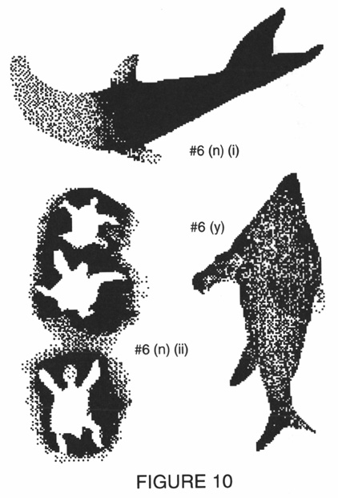FIGURE 10
1972:73, 75), and occurs among the Hawaiian engravings also (Cox and Stasack 1977:19, 64). Turtles are abundant in the waters surrounding Vatulele, as in many parts of Fiji (Derrick 1951:159). 17 Turtle bones occur in midden sites excavated on Lakeba and dated to 300 B.P. (Best 1984, cited in Gibbons 1985:115), apparently a principal food source for the early (Lapita) settlers there.
Finally, #6(y) clearly represents a large fish, though I cannot identify the species. Fish are represented in this realistic silhouette form in the rock paintings of the MacCluer Gulf (now Teluk Berau) of Irian Jaya (Röder 1959:106,108,115,116 and Röder 1955:389,390) and an engraving in South Canterbury, South Island, New Zealand (Bellwood 1979:394 18). The unexpected vertical orientation of the Vatulele fish is also extensively used in the
- 53
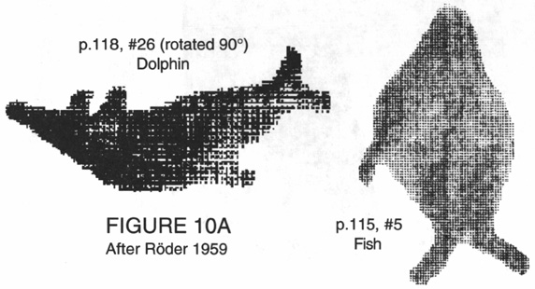FIGURE 10A After Röder 1959
Irian Jaya sites but, judging from the illustration, not in New Zealand. In particular, there is an extremely similar representation of a fish at Wamerei Island, Irian Jaya, from the early period illustrations (Röder 1959:115, No.5).
7. Voyaging canoe.
At Panel #3(a), a small, rather faint image is painted on an irregular surface and can easily be overlooked. On close inspection it may be seen to be a voyaging canoe. Palmer and Clunie saw the painting (or a photograph of it), and illustrated a version of it (1970:7) that involved some major distortions, as the overlay drawing in Figure 11 shows. 19Close examination of the original confirms that it is actually a representation of a double-lateen-sail canoe, with rigging visible which was readily identified by a local informant who has himself sailed Fiji-rigged vessels extensively. 20 While double-sailed vessels of this type were not found in Fiji even at the time of first European contact, earlier voyaging canoes may well have been of this type. Certainly, that was the position arrived at by the researchers who constructed the lsquo;performance equivalent’ replica Hawaiian @@@voyaging canoe ‘Hokule'a’ (see Finney 1979:329-342, Fig.l4.3; Lewis 1977:198-9; Bellwood 1978:43-44). The fully triangular sail seen here is an earlier form (also adopted by the makers of Hokule'a) than that of the twin sails on the va'a motu of Tahiti at the time of European contact (Haddon and Hornell 1975:116-22). There is a further interesting feature of this painting. To the left and above the prow is painted an asterisk-form. Its proximity indicates that this is part of the same picture, and it may indicate a bright star towards
- 54
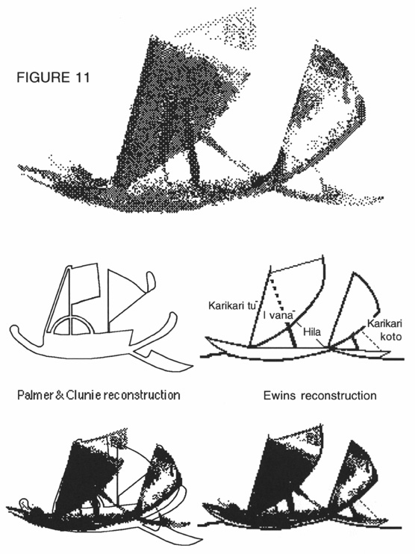FIGURE 11
which the canoe is sailing — a star compass — believable idea, given that astral navigation was certainly one of the skills of the Polynesian voyagers. If so, it may have been intended to indicate the course on which the artist/sailors were set. A peculiarly Pacific device was the use of a ‘zenith star’ which consistently passed over the same latitude. Sirius passes directly over Vanuatu, Fiji and also Tahiti (Lewis 1977:35), and if the illustration is
- 55
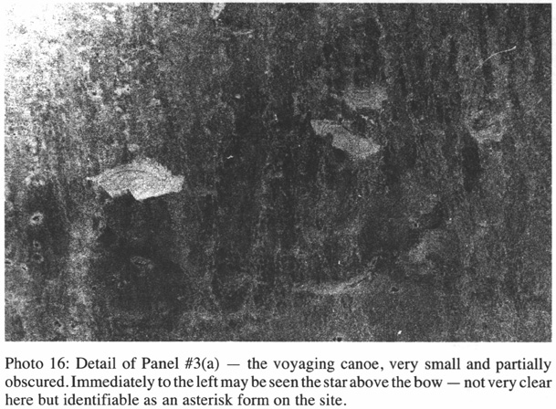
depicting a zenith star, Sirius could be a likely candidate. 21 This possibility is intriguing, since, if it is true, this small painting may represent one of the voyaging canoes of the ancestral Polynesians set on an easterly course which would have brought them from Vanuatu to Fiji and would take them through the Ha'apai Group (Tonga), Niue and the Cook Islands to Tahiti. Any following them, even after a period of centuries, would surely be aware of the astral navigation being used by the trailblazers, indeed would be using the same system, and this tiny, almost obscure painting would provide confirmation that they were ‘on track’.
8. Abstract symbols.
There are in the entire gallery at least eight identifiable abstract symbols, even if one excludes #6(d), #6(r), $6(s) and #6(x) as possibly representational. 22 Most of the symbols are discrete forms, rectangular, ovoid or shield-shaped, with an internal cruciform or x-shaped division. None of these symbols occur in Fijian rock engraving sites.
Three of the images are interesting, each for a totally different reason.
• #6(d) appears to be a bow with a multi-pronged arrow. Bows and arrows were used for shooting fish and birds throughout Polynesia at the time
- 56
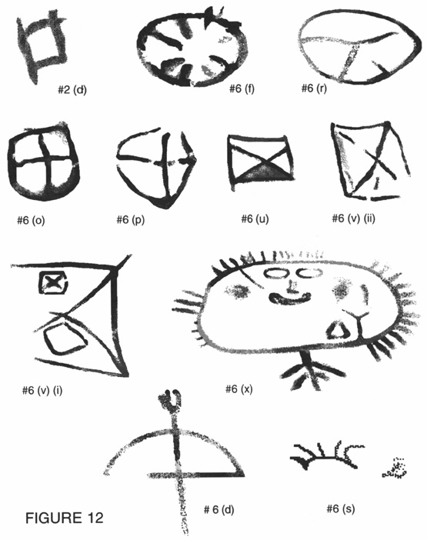FIGURE 12
of western contact (Clunie 1985:11), and multi-pronged arrows of six feet or more were documented by early writers (p.15). Bellwood suggested that the Proto-Polynesian speakers of Western Polynesia about 3000 B.P. did fight with bows and arrows (Bellwood 1978:29). If this was so, by the time of European contact their use as offensive weapons had been abandoned after they left Fiji (Clunie 1985:11-16). However that might be, they were- 57 certainly known to the Austronesian-speaking peoples as gaming weapons from early times, and their use by the Lapita settlers of Fiji for shooting birds and bats has been posited (Gibbons 1985:115). Thus the depiction of a gaming bow and arrow here allows any date of the paintings from the time of western contact back to Lapita settlement.
• #6(v)(i) is a complex diagram resembling a chart, map or plan, which may in fact be joined to #6(v)(ii) which is directly beneath it and actually touching on one corner.
• #6(x) is included here because of its obvious abstract elements, but might equally have been included under ‘faces’ since it has an ovoid shape, has an unmistakable face within its structure (in fact, it is possible to read a face if the image is looked at sideways as well, but this is probably coincidental), and has fringes around much of its circumference. In this last respect, and in the existence of a cruciform ‘tail’ below it, it also bears some affinity with the ‘sun/eagle’ form further north on the same site. 23 If indeed this painting does represent a hunting bow, it may have a bearing on dating the paintings or conversely on dating the use of the hunting bow in Polynesia.
Overview of the Dainaba site
Several points are worth noting concerning the site and the gallery as a whole.
• The cliff-face here, being white, vertical and fairly flat, presents an excellent ‘canvas’ on which to paint, and one which has high visibility from the sea.
• The westward-facing location, though possibly coincidental to a primary concern to procure a good site, does permit speculation on one other possibility. The general migration direction of all settlers and sojourners in Fiji was from west to east, and the paintings may have been intended as ‘markers’ for further ships of the same people who were either expected, or known, to have followed. Given a likely starting-point in Vanuatu, an easterly course would either bring vessels direct to Vatulele, or, after coasting down the Yasawa and Mamanuca Groups in the north-west and west of Fiji, would take them eastwards past Vatulele, and, as mentioned above, the north-western cliff-face shines in the sun like a great beacon, visible for many kilometres. Certainly an easy landmark to spot, and a likely ‘magnet’ for successive voyagers. 24
• Dainaba may have been a ritual site. The ritual nature is suggested rather by evidence of more than one episode of painting, than by the nature of the illustrations themselves, since there is no way of assigning meaning to prehistoric imagery other than by ethnographic analogy from current systems, which is clearly dangerous (Specht 1979:61). One element, however, might- 58 be thought of as sufficiently consistent in Pacific art to suggest ancient convention, and that is the use of red as ‘the colour of the gods’, indicative of mana, and ‘iron-bearing clays, oxidised to red, were used widely in powder or paint form to rub on the bones of ancestors and on objects of special value’ (Barrow 1972:55). Its use for these purposes, as for painting Dainaba and other rock-painting sites (Ballard 1988b: 146), related to both its colour symbolism and its permanence as a stain. The extended time-frame is suggested by differences in density and hue of the pigmentation of the images, and by some appearing to be overlaying earlier images which can no longer be ‘read’. This contention is strengthened by stylistic differences between various images, and by differences of scale even between images next to one another. The largest images are also the faintest, generally red-and orange-ochre coloured, and are evidently the earliest. Many of the smaller images are such a dark red as to be almost black rather than rusty red, with some of them (particularly at Panel #6) overlaying lighter orange-ochre-coloured areas that appear to have been earlier paintings. 25The site may therefore have been revisited, if not routinely, then at least on one or more occasions subsequent to its initial painting, when additions were made to the gallery. The darker, later, images are fewer than the earlier ones, particularly taking into account the number of negative hands, which all appear to belong to the earlier period. The stylistic differences do not appear to me to be so great as to suggest that totally different cultures produced the paintings, but rather that the later, very dark, paintings were produced after a long period of stylistic evolution. This is a quite different situation from that observed by Röder (1955:399-340) for the MacCluer Gulf (Irian Jaya) sites, where the later paintings were clearly done by people of a totally different culture, which he interpreted as being antagonistic to the earlier art. There is no evidence of antagonism in the Vatulele situation — overpainting has only occurred where paintings were very indistinct andfaded.
• The present name for the wave-notches (‘paths of the spirits’) shows that they were noted as unusual and assigned supernatural origins by the ancestors of the current inhabitants. The red prawns are also tabu and may not be eaten or interfered with in any way, and their origin is directly connected by the present inhabitants with the goddess of the particular area (Reed and Hames 1967:163-5, Teckle 1984:32, 430-1). Further, they are able to be ‘called’ by the hereditary priest (bete) of the landowning Narewa clan, who is the traditional servant and mediator of the goddess. It is clearly impossible to extrapolate any direct connection between the beliefs of the present inhabitants and those of earlier peoples, but they do demonstrate the unusualness of the phenomena described, which would always have marked the area out as ‘special’, if not magical, and made it an appropriate site for- 59 ritual and for creating art of particular significance. As far as I have been able to determine, there are no prawn representations on the gallery, which one might perhaps expect if the prawns were considered significant. Conversely, it might be suggested that if they were considered sufficiently magical, taboos might discourage their representation as well as the touching or eating of them as is the case today.
Age of the paintings
‘The dating of rock art is universally difficult’ as Specht wrote in 1979 (p.73). It has not become any easier since then, and none of the conditions which do permit it exist at Vatulele. Any proposals in this regard are thus necessarily conjectural, including those which are discussed in this section. Paine (1929:150-1) suggested that there might be clues to the possible age of the paintings in the elevated wave-notch which exists along the entire length of Vatulele's western cliffs. This represents a relative change in the relationship of the land and the sea-level at some time, either because the sea-level was higher, or because of tectonic uplift and/or tilting of the island, or both. All of the paintings are on the relatively even rockface above this notch, and, as Paine (p. 150) pointed out, today the artists would need to use either a rope or a ladder to paint them. Both devices are, of course, possible, since a form of ladder has probably always been known in the Pacific, but Paine raised another possibility, that of the beach-level which may have existed at the time of cutting of the wave-notch that is now elevated by something like two metres. 26 However the wave-notches were cut approximately 120-140,000 B.P. (personal communication, Kelvin Berryman, NZ Geological Survey, 18 June, 1985), 27 so they were clearly already very old features at whatever period the paintings may have been executed, and they determined the height of the paintings only insofar as these had to be executed above the notches. Today, in fact, while there is no beach at the northern end of the gallery (Panels #l and #2), by Panel #3 there is a sandy beach becoming progressively higher until by the very important Panel #6 it completely fills, and is at the level of the top of, the wave-notch. All but the lowest images however are still substantially higher than could possibly be reached by an artist unassisted, and with an overall height range between 2.5 and 6 m they could not all have been reached from the beach whatever relationship it had to the wave-notches. The fact that the very high images are only stencilled hands, and most of the ‘drawn’ images are in the 3 m-4.5 m AGL range, might just as well be due to the fact that the rock-face is more even there, as to any supposed ground-level. Inaccessibility has indeed been suggested by Ballard (1988a:96) to have been intentional in a large number of cliff-painting sites in Western Melanesia. But whether or not inaccessibility was intentional, it- 60 was an inevitable aspect of muralising such highly visible, functionally and aesthetically desirable cliff-faces.
While concerns about the beach-level functioning as a platform from which to paint are clearly irrelevant, consideration of relative sea-levels and beach-levels does suggest a separate line of investigation. Between 2,000 and 4,000 years B.P., the Pacific Basin sea-level may have reached somewhere between one and three metres above present levels (Nunn 1987:5). This is consistent with the elevation of the sites which have yielded evidence for the so-called ‘Sigatoka’ phase of human occupation in the Sigatoka district on the Vitilevu coast adjacent to Vatulele (Birks and Birks 1968, Birks 1973), by people of the Lapita Culture, 28 which is associated with the maritime ‘Austronesian-speaking, ancestral Polynesian population… that…moved through the Melanesian region to its eastern jumping-off point (Fiji) for the occupation of western Polynesia and from there, eventually, the entire Polynesian triangle.’ (Frost 1979:65). 29 The Lapita deposits, one at the Sigatoka dune site and the other on Yanuca Island some 200 metres off the shore west of Sigatoka occur at heights of 1.7 m and 1.6 m (respectively) above mean high-water mark. They have been carbon-dated between 3100 B.P. and 2000 B.P.. At Sigatoka they have been found in a 28 cm-deep level of grey sand lying directly on top of yellow beach sand, and at Yanuca Island in a 61 cm-deep deposit of sand and marine shell lying on the base of the wave-cut notch. The present Sigatoka dune levels, and the 1.6m height of the Yanuca material lying in the wave-cut notch, indicate an elevated beach level existing at about the time of the known habitation period of Fiji. They also coincide remarkably with the wave-notch below the gallery of Vatulele, which is 1.5 metres above mean high-water mark. The Yanuca and Sigatoka sites are only separated from Vatulele by about 45 kilometres of open sea, so it seems probable both that the notches are the result of the same geological events, and that little change in their relativity has occurred since then. The events which permitted an occupation at Yanuca about 3000 B.P. may then possibly also have obtained at Vatulele, with a strip of elevated beach overlying the now sand-free wide shallow rock platform. This is also, except in times of storm, the sheltered side of the island, and with a sea-level at that height, a great deal of eastern and southern Vatulele, the present occupied area, would have been submerged, leaving limited choices for habitation.
In fact, at least one decorated Lapita potsherd has been collected on Vatulele, 30 extremely similar to the Yanuca material (Clunie 1986:2, Fig.1; Mead, Birks, Birks and Shaw 1975:25, Fig.2.1 and p.28, Fig.2.19 and 2.26) and providing fragmentary but concrete evidence of a Lapita (Austronesian) presence on the island during the early Sigatoka settlement phase. Systematic archaeological work would be required to establish whether the island
- 61
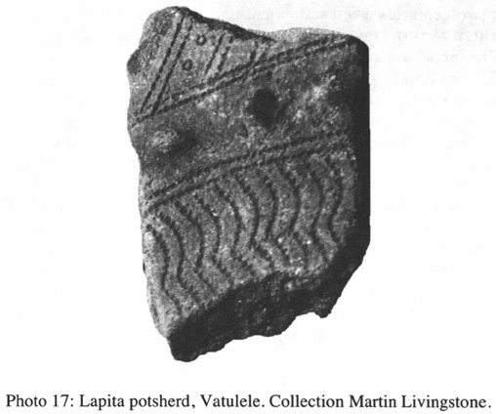
was permanently settled during that period, and, if the principal settlement occurred on a raised beach which is now lost, that may prove difficult. Nunn (1988a:50) has suggested that: ‘People arrived on Vatulele at least c. 3,000 years ago and must have found it quite unsuitable for the establishment of a permanent settlement. They would have found no fresh water, a hard-going topography, and very little soil.’ Nonetheless, such offshore islands were favoured sites for these coastal-dwelling people (Bellwood 1979:247), and, even if they did not settle there permanently, Vatulele possessed significant features (detailed earlier, under ‘Overview of the Dainaba Site’) that would have made it attractive for short-term settlement or repeated visits.
The Sigatoka and Yanuca sites also revealed at least three successive ceramic traditions, with forms and techniques different from the Lapita remains: plainware which appeared between 2500 B.P. and 2000 B.P., impressed decoration dating between 2100 B.P. and 1000 B.P., and the later incised decoration which succeeded it and has persisted up to the present (Frost 1979:65, Routledge 1985:21-5). Vatulele has copious ceramic remains scattered over the surface wherever the ground has been tilled, and those that are decorated are generally from the Incised Tradition. Given the fact that they are on or near the surface, this is not surprising, and most of them appear (on the basis of their decoration, forms and vessel types) to date- 62 from the last two centuries when settlement is verified by oral history and European written record. However, there are also occasional examples of very thin-walled plain-ware and impressed ware which are totally consistent with the two post-Lapita phases of settlement at Sigatoka. It appears, therefore, that there has been a human presence on Vatulele, whether settlement or merely visitation, through much of the two millennia since the initial Lapita presence, though it may have been discontinuous, made up of separate episodes of visitation and/or settlement. The oral history of the present inhabitants indicates a relatively recent arrival date (probably starting mid-18th century) for most of the clans, with only one group, the Nonovahina, claiming to have ‘always been there’ (Ewins, personal field-work interviews), but whether their lineage is, in, fact much more ancient than the other groups will probably never be established. The earlier social organisation of these people appears to have been consistent with that of many groups in Western Fiji, and more comparable with structures existing in much of Melanesia at the time of European contact than with the extremely hierarchical Polynesian-type structures of Eastern Fiji. This difference in Western and Eastern Fijian culture may date from the time of the Melanesian incursion which appears to have occurred in Fiji about 900 years ago, bringing widespread change (Routledge 1985:21, including reference to Best 1984), and continuous occupation of the island since then cannot so far be ruled out. 31 None of which is inconsistent with the ceramic evidence.
Stylistic affinities of the paintings
As mentioned previously, the paintings from the Vatulele site do not resemble the imagery of the numerous rock engravings in Fiji. Nor am I able to discover any obvious connection between the imagery of the paintings and any art forms documented for non-Austronesian Melanesia at the time of Western contact.
The gallery site itself bears interesting topographical similarities to a large number of rock-painting sites in Western Melanesia which have been associated with Austronesian speakers (Ballard 1988a:97-98), and for which dates have been mooted falling between 4000 B.P. and 2000 B.P. (with a suggested likelihood that the latter figure accords most closely with at least some of the sites). Such dates accord with the Yanuca Lapita ceramic date of 3000 B.P., which, as suggested above, is a reasonable proposed period for Lapita presence on Vatulele.
There are copious illustrations of galleries in one of these Austronesian areas, in Röder's (1955 and 1959) comprehensive survey of sites in the MacCluer Bay area of West Irian. Only the earlier sequence he called the Tabulinetin style is of interest, but in that sequence there are at least some- 63 images there which are strongly reminiscent of the Vatulele imagery. The ‘hand silhouettes’ (negative stencil-sprayed hands) noted as this style's ‘most characteristic sign’ (Röder 1955:394) are certainly precisely analogous to those of Vatulele (where they are also the overwhelmingly preponderant form), as is their ochre-to-red colouring. I cannot propose any overall stylistic relationship, although, as pointed out previously, there do exist stylistic affinities between two of the sea-creatures he illustrated for the Wamerei Island site (p.115, No.5 and p.118, No.26) and their counterparts in the Vatulele gallery. Despite the lack of stylisic congruence, the categories of subjects illustrated in the Irian Jaya sites (humans, and local fish and animals) are similar to those in Vatulele, and are also similar to those on some Eastern Polynesian rock engraving galleries. 32 While it is true that their art may reasonably be expected to be significantly divergent, given that the Western Melanesian Austronesians and the Fijian/Polynesians were almost certainly quite different sub-branches in the complex overall picture of early Austronesian expansion (Bellwood 1978:27), and that stylistic evolution was doubtless occurring during successive migration and settlement episodes, nonetheless, all that can be asserted with any certainty at this time is that the Vatulele artists chose a remarkably similar gallery site to those chosen by Austronesian peoples in a large number of sites in Western Melanesia, that both used red staining material, and that both included zoomorphic and anthropomorphic elements in their art.
The establishment of a Lapita Culture presence on Vatulele, important in itself, also establishes the possibility of their authorship of the cliff-paintings, but, from present knowledge, it is not possible to support a case for Lapita authorship on stylistic grounds alone. The specifically decorative nature of the Lapita ceramic art provides no definite evidence of possible conventions that may have been used in their nondecorative ‘mural’ art. This ceramic decoration is predominantly geometric and nonfigurative, and indeed the ‘Mead system’ developed to analyse Lapita material did not identify face designs (Spriggs 1990:83), despite the fact that anthropomorphic faces were noticed as early as 1909 (Meyer 1909: Fig. 6, cited in Spriggs 1990:83 and 1993:7). The relatively complete Lapita faces discovered by Roger Green at Reef Island and Santa Cruz Island, dating from 2100 B.P. to 2500 B.P. (Green 1973:335; 1979a:28 and 1979b:22-23), show a consistency of style which has very few, if any, formal similarities to the Vatulele faces, and offers little support for a Lapita Culture origin for those, 33 and even the geometric forms of Vatulele have every appearance of being symbols, not decoration. In recognising the disparity, however, it should be remembered that Polynesian art, product of the descendants of the Lapita people, 34 is replete not only with geometric but also with figurative forms. While their- 64 decorative art expression in some media bears definite evidence of affinity with decorative ceramic Lapita designs (Green 1979b; 1990), Polynesian nondecorative art does not bear any clear relationship either with the decorative conventions of those same societies, or with the decorative ceramic Lapita designs. There is, to date, so little Lapita sculptural material positively identified that it is impossible to draw any conclusions about its conventions or their transmission to later artists. 35 Further, the Lapita assemblages of Fiji and Polynesia were simpler, more geometric and less obviously anthropomorphic than was Western and Far Western Lapita, and the suggestion that at least some of these could have been highly evolved visual surrogates for faces (Spriggs 1993:7-8) does nothing to advance the case for a connection with the Vatulele paintings (or, indeed, with other Polynesian art). The sophistication of Polynesian figurative art nonetheless testifies to a well-established figurative tradition, which certainly had media-specific conventions in carving which can be seen (from the similarities and differences which existed in the sculpture of different Polynesian societies at the time of European contact) to have continued to evolve slowly as the people moved through Polynesia, and to evolve separately within settled societies. Barrow (1972:55) pointed out that, even in human figure sculptures, some conventions that exist in Melanesia and are ‘of ancient Austronesian antecedence’ are rare in Polynesia. There may well have been, at some stage, other related or variant conventions for painting, 36 What appears to have been an Austronesian ‘mural’ painting tradition was evidently abandoned in favour of rock-engraving as the principal ‘outdoor gallery’ artform further east from Fiji — rock-engraving galleries do indeed occur in a number of locations throughout Polynesia, including New Zealand (e.g., Specht 1979:82, Bellwood 1979:336,394). 37 In sum, different stylistic conventions may have
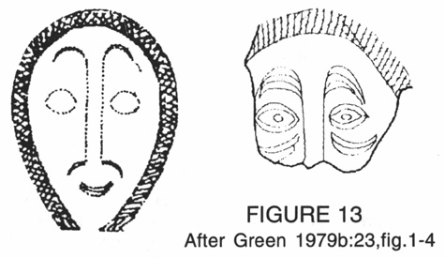FIGURE 13 After Green 1979b:23, fig.1-4
- 65
been employed in the ceramic, painting (assuming it existed) and/or sculptural media of the Lapita culture, and these may well have continued to evolve along different lines.
It has previously been noted that the human figures of Vatulele bear stylistic similarities to some anthropomorphic engravings from Hawai'i (Cox and Stasack 1977). It has also been pointed out that there exist points of similarity between the Vatulele images and one figure and one fish in a New Zealand rock engraving site (Bellwood 1979:394f,a), and two sea-creatures and perhaps one symbol in Austronesian painting galleries from Irian Jaya (Röder 1959). The anthropomorphic figures recorded by Röder, however, are quite unlike those of Vatulele, and those documented for other West Melanesian Austronesian sites by Ballard (1988:151, 153) have a characteristic ‘skull profile’ head which is both distinctive form and dissimilar to the Vatulele figures.
The actual categories of subject matter represented in the petroglyph galleries of Hawai'i, and those of both Irian Jaya and South Island New Zealand (from traditions that had died out several centuries before European contact), are, however, consistent with those of the Vatulele gallery. In each case, the people themselves, some of their artefacts and domestic animals, and local fish, animals and plants, are represented. One interesting feature is that in both Big Island Hawai'i (Cox and Stasack 1977:19,39,50,64) and Canterbury (Bellwood 1979:394h,i,j), (though not in the Irian Jaya sites) dogs are common, but they are completely absent from the Vatulele gallery. This omission may indicate that the Vatulele images were painted at a time before the importation of dogs, which have not yet been established as associated with the Lapita culture (Bellwood 1979:247). The bush fowl which has been clearly identified with that culture is copiously illustrated, whereas for Fiji both pig and dog remains have only been clearly established by about 1000 B.P., in the Lakeba excavation (Best 1984, cited in Gibbons 1985:116).
Subsequent to the Lapita occupation, ‘backwash’ incursions did occur from Tonga, at least into Eastern Fiji. The earliest of these so far proposed is for the 10th century A.D. (Clunie 1986:4), and possibly spasmodically after that until the period of more significant and possibly consistent contact, from about the mid-18th century on until Cession in 1874 (Clunie 1986:181), the period covered by oral history and legends in Vatulele. It is necessary, therefore, to consider the Tongans as possible sources of the ‘Polynesian’ imagery of Vatulele, as well as areas of known Fijian art other than the very different rock-engravings.
There is little prehistoric art documented for Tonga apart from the symbols that have been documented from Tongan rock-engravings (Palmer- 66 1965:36-37), and, while these bear stylistic affinities with some Fiji rock-engravings, they are similarly unlike the Vatulele painted symbols, and offer no support for Tongan authorship of the Vatulele paintings. 38
Figurative elements do occur in the Tongan art which existed at the time of European contact, notably in the very small human figures and zoomorphs of birds, fish, turtles, dogs carved as part of club decoration (Barrow 1972:73-5), and also in the human-figure carvings, in wood and whale-tooth ivory, of the Ha'apai Group (pp.65-71). There are stylistic connections between the human figures on Tongan and Fijian (p.82) clubs and the ‘dancing’ figures of Vatulele, though the club figures are more static and not as directly comparable as the Hawaiian petroglyph figures described previously. The shape of the heads of the Vatulele gallery, particularly those of 3(j) and 6(m), is quite characteristic, and does resemble those of the Ha'apai Group figures, which are in turn like the shape of heads on some of the figures found in Fiji after Western contact (Clunie 1986:82-3). 39 This
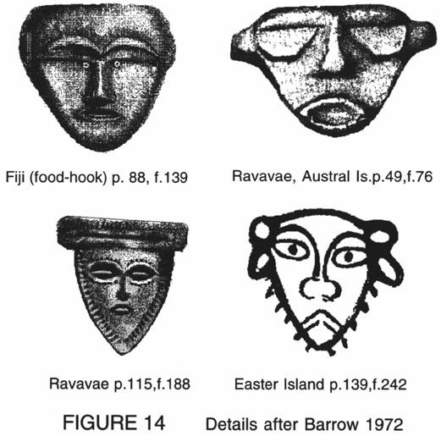FIGURE 14 Details after Barrow 1972
- 67
provides the strongest connection between the Vatulele gallery faces and any found elsewhere in either Fiji or Tonga. Even here, however, the similarities and differences of detail (shape of brow arches, eyes, mouths, ears) are overall neither lesser nor greater than exist with some contact-period faces from Eastern Polynesia (Barrow 1972:49, 115,139). Thus, possible Tongan authorship of the paintings is, on the basis of postcontact imagery, neither more nor less likely than authorship by any other Polynesian group. However, the existence of similarities between the Vatulele figures and figures ranging from precontact New Zealand rock-engravings and pre- and post-contact Hawaiian engravings to contact-period club-engravings in Fiji and Tonga, and between the Vatulele faces and some contact-period sculptured faces from both Western and Eastern Polynesia, does attest to the maintenance in Polynesian society generally of strong figurative conventions, and supports the placement of the Vatulele faces within those conventions.
Summary
I believe that there exist a number of stylistic connections which support placing the Vatulele paintings within the broad context of Austronesian/Polynesian art, while I have not been able to find evidence of affinities with any non-Austronesian Melanesian art. It is not possible to go beyond that very general conclusion on the basis of stylistic affinity alone, however, since the connections tend to be for isolated images, and are not consistently maintained across the total range of images for any other sites I have been able to discover in the literature. In terms of age, one is left with little more than the physical evidence from weathering and calcite veneering that they are of considerable age. More information would be required to establish conclusively an age for the paintings, and it may be unlikely that such evidence is likely to be forthcoming, although there are interesting shared features with Austronesian sites in Western Melanesia which have been ascribed dates in excess of 2000 B.P.. Finally, there is evidence of more than one episode of painting, with the earlier images showing considerable fading and weathering despite the extremely hard rock surface. While it is so far impossible to demonstrate, I believe that there are sufficient elements of circumstantial and stylistic evidence to sustain a conjecture that the earliest paintings may have been made during the early Lapita period of settlement in Fiji.
Acknowledgements
It would be remiss of me to fail to thank the people who have helped me in this exercise: Ratu Mitieli Narukutabua, my friend and unfailing help in all things when I am on Vatulele; Fergus Clunie, whose help and wise- 68 counsel are today sorely missed by all of us who undertake research on things Fijian in Fiji; Chris Ballard, for sharing with me his conclusions relating to his own researches; and Richard Moyle, Paul Geraghty and Jim Specht for reading drafts of the paper and providing much-valued comments and suggestions. Any deficiencies in the article are, of course, my own responsibility and not theirs.
- 69 Page of endnotes
- 70 Page of endnotes
- 71
REFERENCES
- Ballard, Chris. 1988a. Painted Rock Art Sites in Western Melanesia: Locational Evidence for an ‘Austronesian’ Tradition, in Jo McDonald and Ivan P. Haskovec (eds), State of the Art: Regional Rock Art Studies in Australia and Melanesia. Proceedings of the First AURA Congress, Darwin. Occasional AURA Publication No. 6., pp. 94-106. Melbourne: AURA.
- —— 1988b. Dudumahan: a Rock Art Site on Kai Kecil, Southeast Moluccas. Bulletin of the Indo-Pacific Prehistory Association 8:139-61.
- Barrow, Terence, 1972. Art and Life in Polynesia. Wellington: A.H. & A.W. Reed.
- Bellwood, Peter, 1978. The Polynesians: Prehistory of an Island People. London: Thames and Hudson.
- —— 1979. Man's Conquest of the Pacific. New York: OUP.
- Best, Simon B., 1984. Lakeba - the Prehistory of a Fijian Island. Unpublished Ph.D. thesis, University of Auckland.
- Birks, Lawrence, 1973. Archaeological Excavations at Sigatoka Dune Site, Fiji. (Bulletin No.l). Suva: Fiji Museum.
- —— and Helen Birks, 1968. Early pottery objects from Fiji. Journal of the Polynesian Society 77:296-9.
- 72
- Choy, Satish C., 1987. Magico-religious taboos and their contribution to the conservation of the biota of anchialine habitats. Stygologia 3(4):305-12.
- Clunie, Fergus, 1984. Birds of the Fiji Bush. Suva: Fiji Museum.
- —— 1985. Fijian and Tongan War Arrows. Domodomo: Fiji Museum Quarterly 3(1)11-40.
- —— 1986. Yalo i Viti. Shades of Fiji: a Fiji Museum Catalogue. Suva: Fiji Museum.
- Coulson, F. I. E., 1968. Interim report on water supply problems on Vatulele Island (Unpublished Department of Geological Surveys Report FIC/1/68). Suva: Ministry of Natural Resources.
- Cox, J. Halley and Edward Stasack, 1977. Hawaiian Petroglyphs. Honolulu: Bishop Museum Press.
- Cranstone, Brian A.L., 1983. Catching jungle fowl on Vatulele Island. Domodomo: Fiji Museum Quarterly 1(1):7-10.
- De Ricci, J. H., 1875. Fiji: Our New Province in the South Seas. London: Edward Stanford.
- Derrick, R. A., 1951. The Fiji Islands. A Geographical Handbook. Suva: Government Printer.
- Ewins, Rod, 1982. Fijian Artefacts: the Tasmanian Museum and Art Gallery Collection. Hobart: Tasmanian Museum and Art Gallery.
- Finney, Ben R., 1979. Voyaging, in Jennings (ed.), pp. 323-51.
- Frost, Everett L., 1979. Fiji, in Jennings (ed.), pp. 161-81.
- Gibbons, John R. H., 1985. A Brief environmental History of Fiji. II. The Ice Ages and Human Habitation before European Contact. Domodomo: Fiji Museum Quarterly 3(3): 110-23.
- Green, Roger C., 1973. Lapita Pottery and the Origins of Polynesian Culture. Australian Natural History, June: 332-7.
- —— 1979a. Lapita, in Jennings (ed.), pp. 27-60.
- —— 1979b. Early Lapita Art from Polynesia and Island Melanesia; Continuities in Ceramic, Barkcloth, and Tattoo Decorations, in Sidney M. Mead (ed), Exploring the Visual Art of Oceania. Honolulu: University of Hawai'i Press, pp. 13-31.
- —— 1990. Lapita design analysis: the Mead system and its use; a potted history, in Matthew Spriggs (ed.), 1990. Lapita design, form and composition: proceedings of the Lapita Design Workshop, Canberra, December 1988. Occasional Papers in Prehistory No.19. Canberra: Australian National University.
- Haddon, A.C., and Hornell, James, 1975. Canoes of Oceania (Special Publications 27, 28, 29). Honolulu: Bishop Museum Press.
- Hiener, n.d. Untitled. Fiji Museum Archaeological Survey records. Suva, unpublished.
- Hill, W.R., 1959. Rock carvings of Natewa Bay and Na Savu-savu. Transactions of the Fiji Society 6:74-84.
- Jennings, Jesse D. (ed.), 1979. The Prehistory of Polynesia. Cambridge (Mass.): Harvard University Press.
- Kirch, Patrick V. and Terry L.Hunt (eds), 1988. Archaeology of the Lapita cultural complex: a critical review. Seattle: Burke Museum.
- 73
- Ladd, Harry Stephen, 1930. Vatulele, an Elevated Submarine Bank. American Journal of Science, Fifth Series, XIX(114):435-450.
- Land, P.M. 1919. Ancient carvings in a cave at Yasawa. Transactions of the Fiji Society 1919. No pagination.
- Langdon, Robert (ed), 1979. Thar She Went: An Interim Index to the Pacific Ports Visited by American Whalers and Traders in the 19th Century. Canberra: Research School of Pacific Studies, Australian National University.
- Leenhardt, Maurice, 1980. Notes d'Ethnologie Néo-Calédonienne. Paris: Institut d'Ethnologie.
- Lewis, David, 1977. From Maui to Cook: the discovery and settlement of the Pacific. Sydney: Doubleday.
- Martin, K. 1890. Die Kei-Inseln und ihr Verhältniss zur australisch-asiatischen Grenzlinie, zugleich ein Beitrag zur Geologie von Timor und Celebes. Tijdschrift van het Koninklijk Nederlandsch Aardrijkskundig Genootschap(second series) 7:241-274.
- Mead, Sidney M., Lawrence Birks, Helen Birks and Elizabeth Shaw, 1975. The Lapita Pottery Style of Fiji and its Associations. Memoir No.38. Wellington: Polynesian Society.
- Meyer, O., 1909. Funde prähistorischer töpferei und steinmesser auf Vuatom, Bismarck-Archipel. Anthropos4:251-2, 1093-5.
- Nunn, Patrick D.,1987. Sea-level and Tectonic Changes in the Pacific Basin, With Emphasis on Holocene Changes in Fiji. Domodomo 5(1):4-15.
- —— 1988a. Recent Environmental Changes Along Southwest Pacific Coasts and the Prehistory of Oceania: Developments of the Work of the Late John Gibbons. Journal of Pacific Studies (14):42-58.
- —— 1988b. Studies in the Tectonics and Structure of Southern Fiji. Part 1: Geology, Geomorphology and Structure of Vatulele island; Implications for Local and Regional Tectonics. SSED Working Paper No.10. Suva: University of the South Pacific.
- Paine, R. W., 1929. Some Rock Paintings in Fiji. Man (109):149-51.
- Palmer, J.Bruce, 1965. Petroglyphs in Tonga. New Zealand Archaeological Newsletter 8(2):34-38.
- —— and Fergus Clunie, 1970. Rock paintings and engravings in Fiji. (Fiji Museum Educational Series #1). Suva: Fiji Museum.
- Parke, A.L. 1961. Archaeology in Fiji. Transactions and Proceedings of the Fiji Society 8(1960-61): 10-42.
- Parry, John T. and Dick Watling, 1988. Petroglyphs at Maqere, Tavua, Vitilevu. Domodomo: Fiji Museum Quarterly. 1988 (1-4):106-113.
- Phillipps, W.J., 1951. Rock Spirals of Fiji. Journal of the Polynesian Society 60:51-53.
- Pietrusewsky, M., 1993. Lapita origins: an osteological perspective, in Philip J.C. Dark and Roger Rose (eds), Artistic heritage in a changing Pacific. Bathurst: Crawford House Press, pp. 15-19.
- Rao, B., 1984. Vatulele Geology. Note BP13/9 (Unpublished). Suva: Mineral Resources Department of Fiji.
- 74
- Reed, A.W. and Inez Hames, 1967. Myths & Legends of Fiji. Wellington: A. H. & A.W. Reed.
- Röder, Josef, 1955. Rock paintings of the MacCluer Bay (Western New Guinea). Antiquity and Survival 1(5): 387-400.
- —— 1959. Felsbilder und Vorgeschichte des MacCluer-Golfes West-Neuguinea. Darmstadt: L.C. Wittich Verlag.
- Routledge, David, 1985. Matanitu: the struggle for power in early Fiji. Suva: University of the South Pacific (Institute of Pacific Studies).
- Snow, Philip A., 1953. Rock carvings in Fiji. Transactions of the Fiji Society 4(1948-50):71-80.
- Specht, James R., 1979. Rock Art in the Western Pacific, in Sidney M. Mead (ed.), Exploring the Visual Art of Oceania. Honolulu: University of Hawai'i Press, pp. 58-82.
- Spriggs, Matthew (ed.), 1990. Lapita design, form and composition: proceedings of the Lapita Design Workshop, Canberra, December 1988. Occasional Papers in Prehistory No.19. Canberra: Australian National University.
- —— 1993. How much of the Lapita design system represents the human face? in Philip J.C. Dark and Roger Rose (eds), Artistic heritage in a changing Pacific. Bathurst: Crawford House Press, pp. 7-14.
- St. Johnston, A., 1883. Camping among the cannibals. London: Macmillan.
- Sugimura, A., Y. Ida, K. Berryman, T. Miyata, T. Ishii, Y. Maeda, Y. Matsushima, N. Yonekura, 1984. Sea-level Changes and Tectonics in the Middle Pacific. Report of the HIPAC project in 1981, 1982 and 1983. Kobe: Department of Earth Sciences, Kobe University.
- Teckle, Belanaish, 1984. The Position of Women in Fiji: Vatulele, a Case Study. Unpublished Ph.D. thesis. Sydney: Department of Anthropology, University of Sydney.
- Trotter, M. M. and B. McCulloch, 1971. Prehistoric Rock Art of New Zealand. Wellington: Reed (republished 1981, Longman Paul).
- Vogan, A. J., 1937. Recent archaeological discoveries in the Western Pacific. Journal of the Polynesian Society46:99-104.
- Williams, Thomas, 1858. Fiji and the Fijians: Vol.1: the Islands and their Inhabitants. London: Alexander Heylin.
1 Specht (1979:65-67) indicated that limestone was the substrate in 95% of cases where the geology of Pacific rock-painting galleries was known.
2 Although they are not documented in the literature, I have been informed of another site in a cave near Lovoni, Ovalau (personal communication, Paul Geraghty), and some paintings may also exist in Totoya, western Lau (see Note 21).
3 Specht (1979:73) states of Pacific rock-art generally that ‘in the majority of cases the local inhabitants deny knowledge of either the age or makers of rock-art.’
4 Location of the Vatulele Island Resort.
5 Personal communication, Ratu Mitieli Narukutabua.
6 If the thickness is measurable and the rate of accretion able to be estimated, it may provide a physical means of estimating the age of the paintings.
7 Fortunately, their considerable height above ground-level helps preserve the paintings themselves, but there has, in fact, been some graffiti damage to lower sections of the cliff. It should be noted that all of this is apparently (from the names scrawled on the cliff) by indigenous Fijians, and there is no evidence that the organised tourist visits are resulting in any damage.
8 Including the neighbouring island of Beqa (Phillipps 1951).
9 This is relevant to later discussions of medium-influenced stylistic differences.
10 Similar headdress fringes occur on some cliff-painting figures from the Moluccas group (Ballard 1988b:154 and 153, fig.8), but the figures themselves are stylistically quite different from those of Vatulele or the Polynesian sites mentioned.
11 After Trotter and McCulloch (1971).
12 There would be problems with viewing this painting, or the gallery as a whole, as the work of New Caledonians. There is no record of any New Caledonian incursion into Fiji, and geographically either the settlement of Fiji or later contacts direct from New Caledonia would appear rather unlikely. If the view is taken that these pictures were painted by ancestral Fijians some time after their separation from the Lapita stock in Vanuatu who also gave rise to the ancestral New Caledonians, this would imply the continuity of wearing such headgear in New Caledonia for at least 2000 years. This may, however, not be unreasonable given that it was an indicator of elevated social rank and was a fairly basic item of apparel, along with the loin-cloth.
13 See discussion under the later section, ‘Overview of the Dainaba Site’, and associated notes.
14 Previous note applies here, as does discussion under ‘Stylistic Affinities of the Paintings’.
15 The paintings were noted by Paine (1929:109-110) and Palmer and Clunie (1970:11), who, in pointing out the name manu hegwa, speculate that this is a ‘survival from an ancestral language linked with Polynesian and could be interpreted as bird of the land, i.e.a native bird’. This is incorrect. The language is not ancestral but modern and unexceptional — in Vatulele dialect, manu means ‘chicken’, and hegwa means ‘feral’, or ‘wild’.
16 Personal communication, 1985, by William Clark, resident of Korolevu. The incident was not unique: they have also been reported from both Ono and Matuku in the Lau Group (personal communication, Paul Geraghty). Paine's depiction of this image as a bird (1929:110) was followed by Palmer and Clunie (1970:7), but I disagree with both.
17 Today the consumption of turtles as food in Vatulele is restricted to the chiefly Nalimolevu clan (a chiefly prerogative in a number of other parts of Fiji also).
18 After Trotter and McCulloch (1971).
19 They comment (p.11) as follows; lsquo;A canoe painting seems to represent a large craft with pennant flying, one triangular and one square sail with the large steering oar out. Although similarities can be drawn with canoes from other areas there are just as many points of difference in each case. It would seem that a special type from nearby Kadavu Island is intended with some license on the part of the artist being displayed.rsquo; Clunie has indicated (personal communication, 1985) that he no longer accepts the ‘Kadavu’ explanation, and that he has been unable to find any known vessel or sail configurations in the Pacific which tally with their interpretation of the painting. The difficulty lay in their incorrect transcription, which was perhaps caused by a reliance on photographs without back-reference to the original, but, even then, there were some major distortions of proportion and form to achieve the result.
20 Ratu Mitieli Narukutabua. The names given on the illustration are in the language of Vatulele. The upper yard remains karikari tu (‘upstanding yard’) in Standard Fijian. The lower yard (boom) is karikari sila, from the fact that it carries the mainsheet, sila, whereas in Vatulele it is called karikari koto (‘lying down yard’). The mast is i-vana in both languages. Whether indeed the sila (hila in Vatulele) or mainsheet is what the secondary lines represent, or whether they are meant to be the heftier mast-stays, is difficult to say.
21 In July 1993 a team led by Dr Patrick Nunn of USP began an investigation of a reputed cliff-painting site on Totoya island in the western Lau Group, Fiji. The results of their findings are not yet available, but if they are, in fact, paintings rather than engravings, and if they prove to be related to the Vatulele paintings, this would support the Sirius hypothesis, since anyone sailing in Sirius' path east from Vatulele would pass north of Totoya but in clear sight of it.
22 Palmer and Clunie stated that ‘the only abstract form seen in the series is a shield-like motif...whose significance has been lost’. The motif they refer to and illustrate is #6(o). It is strange that they missed #6(p), which is less than two metres south and half a metre lower on the cliff-face. As suggested previously, they were probably working from photographs and had incomplete coverage, but most of the symbols (all except two of them) do occur in the large Panel #6 area, and the fact that only one was noted indicates a very cursory survey.
23 There is a cruciform appendage reminiscent of this one, on an anthropomorphic engraving at Tipaerui Valley, Tahiti, associated with a phallus but noted as unclear ‘whether it indicates a male or female’. (Barrow 1972:108, Fig.178).
24 Ballard (1988a:96-7) pointed out that high visibility is a characteristic of most of the cliff-sites in Western Melanesia that he considered were associated with Austronesian-speaking peoples. Röder (1955:387) wrote of the sites in Irian Jaya that ‘the steep white cliffs of the projecting spurs cast their gleam far away over the water…’
25 Ballard (1988b:148) declined to attempt to assign age on the basis of colour, though he noted at the Dudumahan site that there was, similarly, a considerable variation in colour from dark rust red to light orange. I believe there are grounds for relating colour variation to age in the Vatulele site. First, because there is a progressive lightening of colour adjacent to areas where the images have weathered away. This indicates, perhaps predictably, that the colour is light where it is a thin (transparent) layer only, and its association with weathering is, I suggest, a fair indication of greater age. Second, in all cases I noted where overpainting had occurred, the underneath colour was lighter, and there was an associated stylistic difference between the lighter images underneath and the darker ones over them (in this, my observations accord with Röder (1955:393), where for the MacCluer Bay sites he spoke of ‘overlying paintings of later date displaying pronounced stylistic divergences can be distinguished from the earlier layer of red-figured paintings’). I do, however, agree totally with Ballard's conclusion that colour difference could not be used for ‘fine definition’ as a measurable variable.
26 A proposition for uplift playing a part in making cliff galleries inaccessible had been put as early as 1890 (Martin 1890, cited in Ballard 1988a:96).
27 In the letter cited, Dr Berryman guessed that the age of the notches relates to the last interglacial period when sea-level stood 6±4 m above present.
28 The literature on the Lapita Culture is copious. Green (1979b) provided a succinct summary, and there are other useful summaries also in Bellwood (1979) and Frost (1979). More current and comprehensive works include Kirch and Hunt (1988), and Spriggs (1990) (including an overview chapter by Green).
29 The Lapita ceramic tradition is defined as ‘the logical point to begin explanations of the nature of ancestral Fijian culture’ (Frost 1979:65), and the Sigatoka Phase Lapita pottery ‘shows a continuous distribution from Eastern Melanesia to Western Polynesia’ (p. 65).
30 The shard was given in 1990 by the Fijian who found it to the manager of the Vatulele Island Resort hotel, Martin Livingstone, who has it in his possession.
31 The Nonovahina's oral history describes a nonhierarchical ‘collective’ social organisation which appears more reminiscent of Melanesian ‘big man’ organisation than of typically hierarchical Polynesian structures. They may, therefore, have arrived with the Melanesian influx about 1000 B.P.
32 For simplicity, I am here using Eastern Polynesia in the sense in which Bellwood (1979:308) used it, to include Hawaii and New Zealand.
33 Palmer and Clunie (1970:11) describe the Panel #6 faces as being ‘done in an archaic style found in various Pacific islands’. I am unaware of which models they may have been referring to, and rather suspect it was an unsubstantiated generalisation.
34 While debate continues about this matter, Pietrusewsky (1993:18) concluded that ‘univariate comparisons of Lapita-associated skeletons from several different archaeological sites indicate affinities with Polynesians.’ He went on to say that ‘Focusing on near contemporary populations, the present results … suggest it is impossible to derive Polynesians from Melanesians, and further offers new evidence that Polynesians are closely related to South-East Asians.’ He cautions that all of these conclusions should as yet be viewed as tentative.
35 Green (1973:334) illustrated one tiny (3.8 cm high) ceramic sculpture of a bird from Santa Cruz, and (1979b:17) a fragment of a supposed human figurine.
36 It has been suggested earlier that there is at least some evidence of a connection between the heavy stylisation of the Vatulele faces and of sculptural conventions.
37 They are stylistically quite distinct from Fijian engravings.
38 There are also interesting connections drawn by Palmer between some of the Tongan engravings and others from Samoa, the Marquesas Islands and Hawai'i.
39 Whether these originated from the same Tongan source is unclear.

