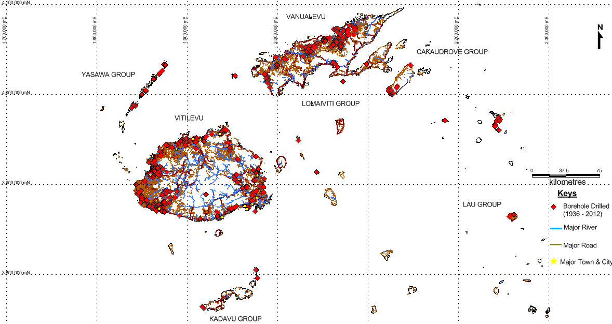
Major Boreholes drilled in Fiji (1936 - 2012)
Groundwater is water located beneath the earth's surface in soil pore spaces or fractures and crevices of rock formations. Recharge of groundwater comes largely from rainwater in addition to seepage from rivers, creeks and lakes.
In Fiji, groundwater is an ever increasingly important source, supplying the demand for water supply in peri-urban and rural communities on the main islands and outlying small islands. It is also important for irrigation purposes (example, Sigatoka Salad Bowl, Nadi –Lautoka and Rakiraki region), and for commercial exploitation as the choice water source for most bottled mineral water factories in the country.
Ground water can be accessed by drilling or digging wells. There are also some artesian wells in Fiji, wells drilled into an artesian aquifer may result in water freely flowing out of the borehole.
Groundwater can become unusable if it becomes polluted and is no longer safe to drink. We can also run out of groundwater if more water is being discharged than recharged. However, careful use and reducing sources of pollution can ensure groundwater continues to be an important natural resource in the future.
The state of groundwater resources in Fiji is measured by 3 indicators: 1) groundwater quality, derived by chemical measurements of nutrients, faecal coliforms and metals, 2) groundwater quantity or availability, derived by recharge rates or instances of wells going dry and 3) exploitation of groundwater resources in Fiji to date.

INLAND WATERS
GROUNDWATER: Groundwater quality, availability and exploitation

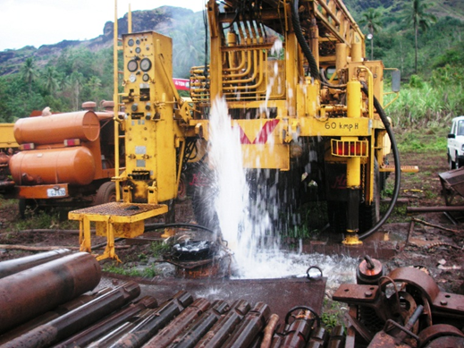
GW Drilling in Small Islands-
MRD Drilling Project


Status: Good, Trend: Stable, Confidence: Medium
Overall, the majority of Fiji’s groundwater resources are pristine and abundant. However due to the increasing population and development in rural and peri-urban areas, groundwater resources are increasingly under pressure from physical, chemical and microbiological pollution, in addition to overuse.
Quality: Metals and nutrients in groundwater resources are generally low, however, in the Northern Division, some boreholes show microbial contamination (faecal coliforms) from agriculture and urban development. Water from these boreholes are treated prior to human consumption. There are also a few cases of saline intrusion in the outer islands and in the coastal regions of the main islands, where the water table is close to sea level.
Quantity: In general, groundwater is abundant throughout Fiji, particularly on the main islands of Viti Levu, Vanua Levu and Taveuini. Small island groundwater resources in Fiji are inevitably exhausted from time to time due to the high demand of water to meet the needs in the villages. Education on groundwater management is crucial in these communities to ensure wells are protected from pollution and overuse.
Exploitation: Exploitation of groundwater resources is increasing, particularly where there are few alternative sources for drinking water. Currently the MRD has ~ 800 wells drilled throughout Fiji, 200 of which were drilled in the past 10 years. In addition, the bottled water industry has grown in the past 20 years significantly and there are now at least 8 viable commercial bottling boreholes in Viti Levu. Most boreholes exist western, drier side of the main islands.

GROUNDWATER: Groundwater quality, availability and exploitation

INLAND WATERS

*ANZECC: The Australian and New Zealand Environment and Conservation Council

Faecal Coliforms: Northern Division Boreholes (from WAF Water Quality Laboratory)
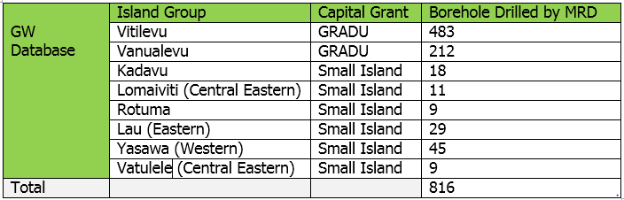Boreholes drilled by MRD 1936 to 2012
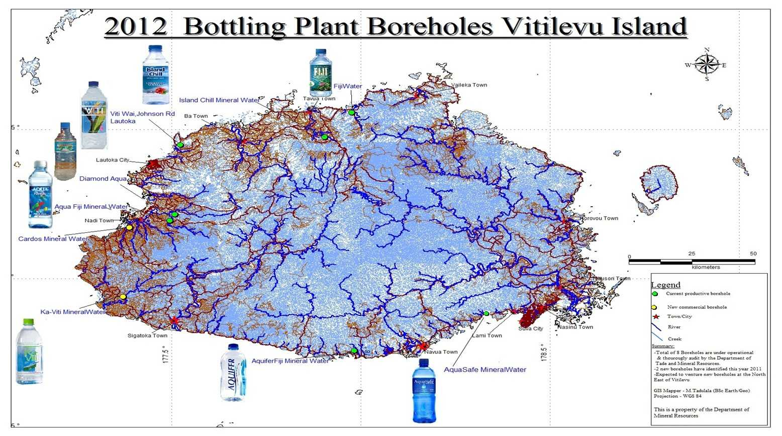
GROUNDWATER: Groundwater quality, availability and exploitation

INLAND WATERS

Bottling Plant Boreholes on Viti Levu

Impact:
Overuse of groundwater can impact the availability and quality of groundwater for future generations. Poor land management can also impact groundwater quality through contamination of groundwater sources. In Fiji, these risks are higher for the small island communities that have limited water availability and susceptibility to saltwater intrusion.

Fiji's recent growth in the bottled water industry has led to increased exploitation of groundwater, and if managed well, can be continued sustainably. Groundwater resources contribute directly to the economy through production and export of good quality bottled mineral water through the foreign earnings, the taxes, the employment created and other streams of revenue generated by the commercial use of groundwater. The bottling industry has also led to an increase in public knowledge and awareness of groundwater resources, with its labeling describing groundwater and how it originates. This has greatly helped in raising awareness of groundwater resources and how to care for them properly.

The trend in quality and quantity is envisaged to improve and increase due to the existence of the Environment Management Act which is the principal law for the protection of the environment including groundwater environment and resources. There is also the requirement for Environment Impact Assessments and Environment Management Plans to be developed as part of any development that may have an impact on the groundwater resources.

INLAND WATERS
GROUNDWATER: Groundwater quality, availability and exploitation

Response: What is Fiji doing to protect and sustain our groundwater resources?
Current activities:
- Monitoring water levels and groundwater chemistry of the MRD groundwater boreholes monitoring network.
- Community awareness activities and programs to help educate locals of the need to sustainably use groundwater resources
- Quantity monitoring (based on rates of extraction) – Specifically evaluated the status of water quantity for aquifer
- Water Quality Monitoring by the Water Authority of Fiji (WAF) in regional drinking water supply boreholes, including microbiological, metals and nutrient monitoring
- Development of a National Groundwater Database – For groundwater resources information of Fiji
- The implementation of Fiji’s Environment Management Act and the Environment Impact Assessment requirement for any development that would have a possible negative impact on groundwater resources.
- The development of Fiji’s National Water Resources and Sanitation Policy as an overarching water resources policy.
- The development of a Groundwater Management Policy that aims to manage and protect the use of groundwater resources.
Planned activities:
- Development of groundwater a modeling exercise in regional water supply (WAF boreholes) and commercial bottling areas to ascertain the characteristics and extent of the supply aquifer.

