THREATENED SPECIES: Number, State of Knowledge and Recovery Plans
BIODIVERSITY

The Fiji Flying Fox: Fiji’s only endemic mammal, rare and data deficient Source: NatureFiji-MareqetiViti.
Fiji is rich with land and marine plants and animals. Much of Fiji's marine biodiveristy is shared with neighbouring countries in the Pacific. It is on the land that Fiji's endemic species (species that only exist in Fiji) dominate. Of the known endemics in Fiji, only 20 in the marine environment are currently documented compared to 926 known endemics in the terrestrial environment.
Fiji tracks the status of its species through several international and national programs, these include:
- The IUCN Red List, which is a comprehensive inventory of the global status of plant and animal species that include 9 status categories. 3 of these categories qualify as "Threatened" status and include Critically Endangered, Endangered and Vulnerable.
- The Convention on International Trade in Endangered Species (CITES).
- Species indentified in Fiji's Biodiversity Strategy and Action Plan (NBSAP 2007)
- Species listed in Fiji's Endangered and Protected Species Act (2002)
- Other species (endemic, culturally important or occurring in an endangered ecosystem) identified by local experts
For this indicator, 3 general criteria were used to assess the status and trend of threatened species in Fiji. These are:
- The estimated number of threatened species as percentage of known species for animal and plant groups
- The "state of knowledge" about Fiji's threatened and endemic species
- The number of recovery plans to re-establish and/or protect endangered species.

BIODIVERSITY
THREATENED SPECIES: Number, State of Knowledge and Recovery Plans

Table 1: Status of Fiji's Biodiversity (from Nunia Thomas: NatureFiji-MareqetiViti)
Group | Total number of known living species | Number of introduced species | Number of known living, native species | Number (% of native species) endemic to Fiji | Number currently threatened or endangered
Terrestrial
Birds | 68 | 11 | 57 | 27 (48%) | 17
Mammals | 17 | 11 | 6 | 1 (17%) | 2
Amphibians | 3 | 1 | 2 | 2 (66.6%) | 2
Reptiles | 27 | 6 | 21 | 12 (57.1%) | 3 (probably an underestimate, needs more research)
Invertebrates | More than 5102 – research ongoing | Research on-going | Research on-going | Research on-going | Research on-going
Freshwater fish | 161 | 10 | 151 | 11 (7%) | Research on-going
Plants | 2543 | 949 | 1594 | 893 (56%) | 281
Marine
Fish | 1198 | 15 | 1183? | 14 (1 %?) | 49 – Research on-going
Mammals | 12 |  |  | 0 | 8
Reptiles | 10 | 0 | 10 | 0 | 3
Invertebrates | 1056 | ? | ? | 3 (1%?) | Unknown
Plants | 426? | ? | ? | ? | ?

THREATENED SPECIES: Number, State of Knowledge and Recovery Plans
BIODIVERSITY

State: Poor, Trend: Unknown, Confidence: Low
The three dominant messages about the state of threatened species in Fiji are:
1) The majority of Fiji's endemic species are terrestrial and generally face a higher level of threatened status than their marine counterparts (refer to Table 1 and the graph below). The greatest pressures faced by terrestrial species are clearing of the native forests and the spread of invasive plants, insects and animals.
2) For many species in Fiji, there is not enough information to make a sound assessment on their numbers and state. While there is a general consensus that many endemic populations are declining, new information is showing that there have been both underestimates and overestimates on the state of several species. For example, recent targeted surveys of the long legged warbler (critically endangered) show higher numbers than thought previously. Without this information it is difficult to both prioritize species of concern and develop effective protection and recovery plans.
3) There are recovery plans for 6 threatened species in Fiji: The Sago Palm, the Mirimiri bat, the Crested Iguana, the Red Throated Lorikeet, Sea Turtles and the Fiji Petrel. The efficacy of these plans is yet to be fully determined and is discussed in the next indicator on species of concern. The low ratio of recovery plans to threatened species reflects the generally low state of knowledge about Fiji's threatened species.
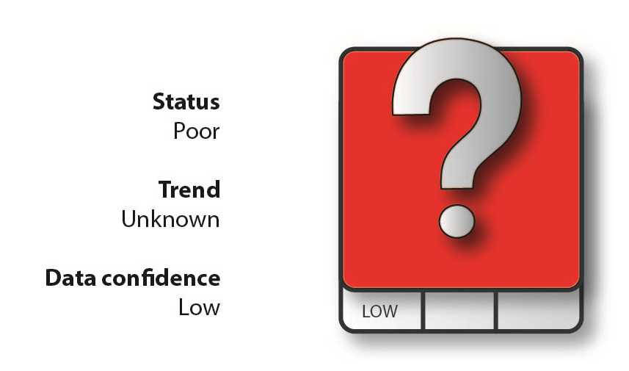

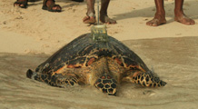
The critically endangered Hawksbill Turtle, a native of Fiji. Between 1984 and 1989 alone , more than 5, 000 Hawksbill turtles were killed in Fiji for export of the shell) Traditional practices or anointing of chiefs included the harvesting of turtles, although this has been moderated in recent years. Source: NatureFiji-MareqetiVitii

BIODIVERSITY
THREATENED SPECIES: Number, State of Knowledge and Recovery Plans

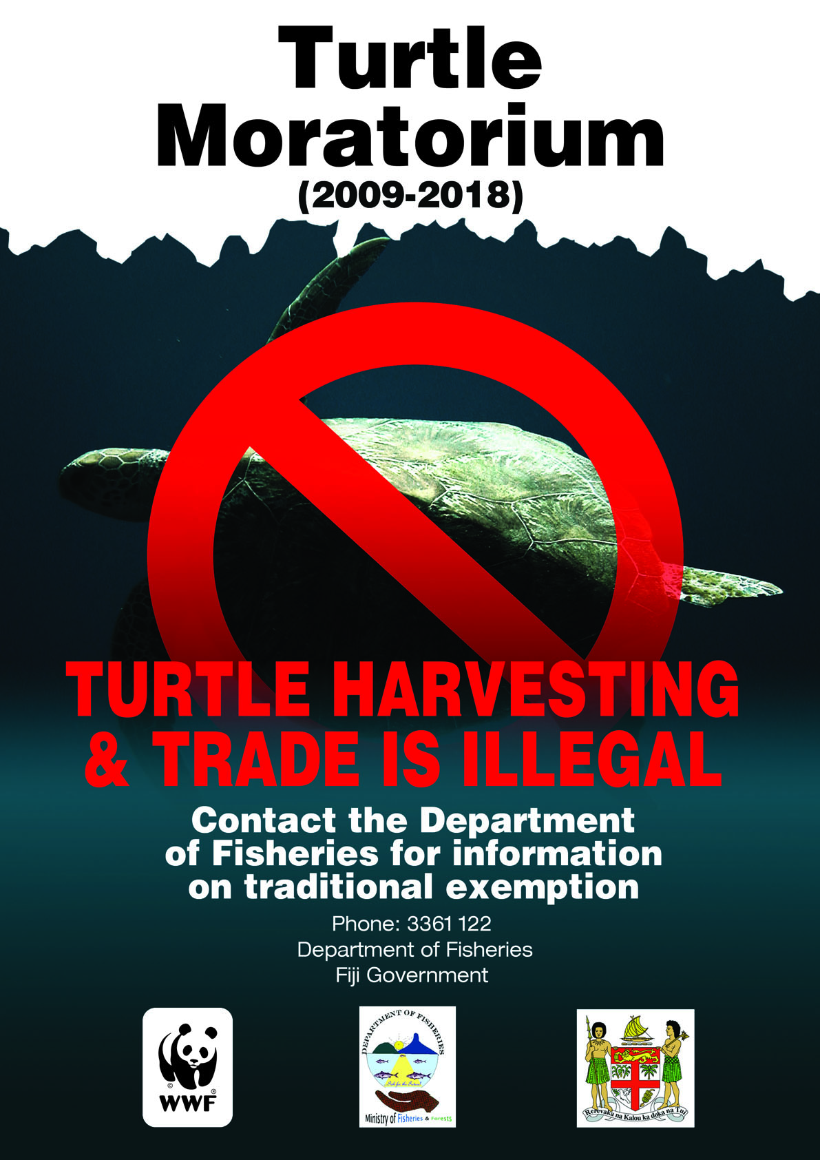
As part of Fiji's Sea Turtle Recovery Plan, a turtle harvest and trade moratorium is in place in Fiji. Illegal harvesters face stiff fines. Source: WWF-Fiji
Impacts to Fiji
A number of threatened species in Fiji have social, economic and cultural importance to Fiji. Many of these species are unique only to Fiji and are a source of national pride.
Furthermore, Fiji’s biodiversity has evolved together and have developed interdepent relationships to help them adapt to Fiji’s physical conditions. The loss of certain groups will have impacts on the ecological health of Fiji's unique ecosystems. that exist in Fiji.

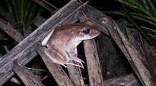
The Fijian Ground Frog: One of 2 known endemic frog species in Fiji that are threatened by loss of habitat and invasive species such as the mongoose, the feral cat and the cane toad. Source: NatureFiji-MareqetiViti

Fiji Response to Threatened Species and further recommendations:
Current efforts to protect our endangered species include:
- Ongoing research by government, NGO's and universities to aid in prioritization of species requiring attention and management.
- Moratorium on turtle harvesting
- Development of recovery plans for species at risk.
- Targets of NBSAP, CITES streamlined into National Policies.
- RAMSAR, CITES, establishment of Fiji’s CBD clearing house mechanism to facilitate information sharing
- Locally managed marine protected areas (MPAs) in Fiji are playing an increasingly important role in the protection of marine threatened species
- Identification of key biodiversity areas in Fiji by expert stakeholders and management plans to protect them
Recommendations:
- Continue research and data collection on priority species
- Prioritize and advance terrestrial protected areas to conserve remaining species

THREATENED SPECIES: Number, State of Knowledge and Recovery Plans
BIODIVERSITY

Sources:
Thomas, Nunia. "Endangered Species of Fiji Project" in Fiji, 2008. NatureFiji-MareqetiViti. www.naturefiji.org.
Fiji State of Birds 2013, A Guide for Conservationists, Policymakers and Communities, NatureFiji-MareqetiViti
Photos sourced from www.naturefiji.org used by permission of NatureFiji-MareqetiViti

'

