Introduction
Terrestrial protected areas are totally or partially protected areas of at least 1,000 hectares that are designated by national authorities as scientific reserves with limited public access, national parks, natural monuments, nature reserves or wildlife sanctuaries, protected landscapes, and areas managed mainly for sustainable use
They are significant in promoting species resilience by limiting anthropogenic pressures and essential to biodiversity conservation
Thesize and number of our terrestrial protected areas informs us of the degree of our terrestrial conservation efforts and the value we place on particular ecosystems and resources.
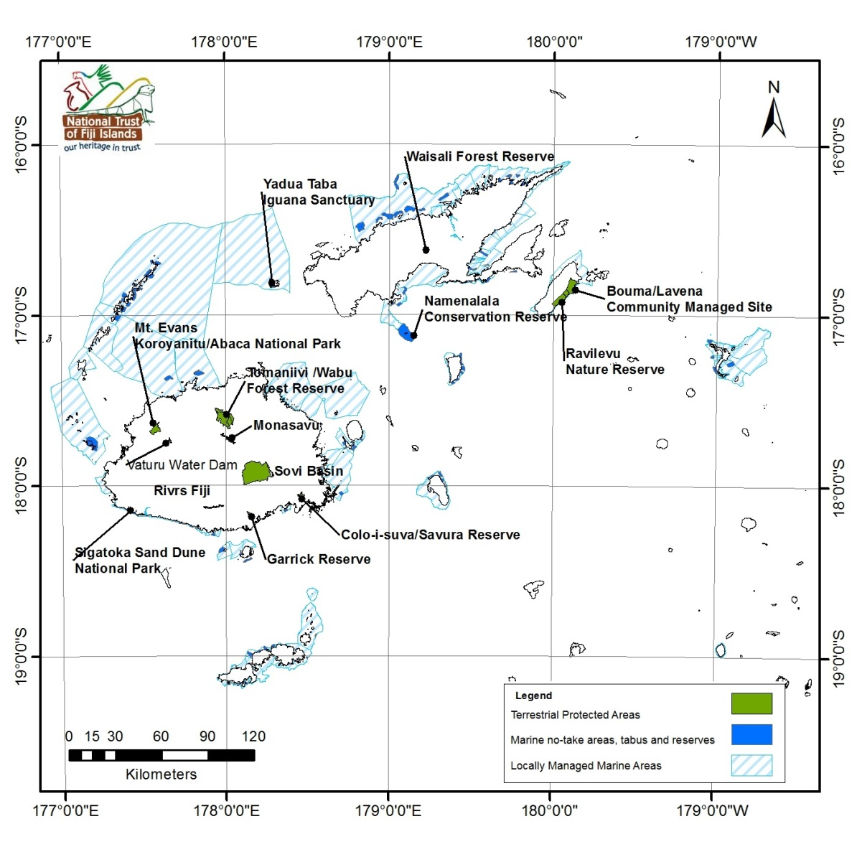
Source: National Trust of Fiji (2013)

State
There are currently 32 existing terrestrial protected areas in Fiji. They make up a total land area of 209.48km² on VitiLevu and 234.22km² on Vanua Levu and Taveuni; the latter being larger attributing to the size of the forest reserve on Taveuni (110.89km²). Fiji’s existing protected terrestrial areas total 443.70km2, while proposed terrestrial areas 2246.84km2.
Terrestrial protected areas (as % of total land area) in Fiji was 1.34 as of 2010 (UNEP, 2010) with its highest value over the past 20 years reported to be 1.34% of total landmass in 2010, and lowest value at 1.07% in 1990

Source: UNEP, 2010
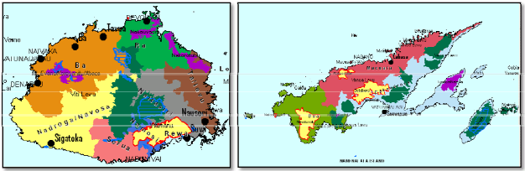Source: Jupiter et al (2010)
On the above maps of Fiji’s two main islands, existing terrestrial protected areas are highlighted in blue; proposed forest protected areas where steps have been taken to initiate management but currently lacks formal protected are highlighted in purple; high priority areas without any management (in yellow with red border), and key biodiversity areas in dark green.
Impacts
Protected areas simply allow the land to replenish itself relatively free from human exploitation. Protecting our forest reserves for example directly helps prevent the ongoing loss of biodiversity. Protected areas also replenish species population, promote better stewardship by landowners and offer long term rewards with healthy ecosystems promoting national sustainable management of resources and more resilient communities
What is Fiji doing about our Protected Terrestrial Areas?
Fiji has a National Protected Areas Committee (PAC) that was established in 2008 under section 8(2) of Fiji’s Environment Management Act 2005 in order to advance Fiji’s commitments under the Convention on Biological Diversity (CBD)’s Programme work on Protected Areas (PoWPA). The PAC has established national targets for conservation and management, collated existing and new data on species and habitats, identified current protected area boundaries, and determined how much of Fiji’s biodiversity is currently protected through terrestrial and marine gap analyses. The terrestrial working Group for the PAC iscomposed of representatives from the University Of theSouth Pacific (USP) Herbarium, Conservation International (CI), National Trust Of Fiji (NTF),BirdLife International And NatureFiji/MareqetiViti.

Change to fair, trend improving, confidence High

Terrestrial Protected areas:
Only 2.7% fully protected under regulation. If we continue as is with protected areas as currently defined in Fiji's legislation, there will likely be no increase. If all proposed sites (including Key Biodiverity Areas, Important Bird Areas and Priority Forest areas) became protected under the IUCN management categories (range of different management criteria that are defined under protected areas) the number would 18%. These sites may be vulnerable without protection. By changing this definition it increases the management options available for these areas and encourages the designation of these areas as protected.
Of the 2.7% Management is varied. Some are managed by National Trust, some by Forestry, and some are community or privately managed. Most do not have management plans in place. National Trust is currently piloting management plans for Sigatoka Sand Dunes National Park and Sovi Basin Protected Area.
A number of the proposed sites currently have some management arrangements through work being carried out by government and NGOs (e.g. Redd +, GEFPAS) where boundaries and biodiversity significance and management needs are being refined.
Response:
1) Sustainable financing for ongoing management
2) Pursue equitable sharing of benefits from conservation for resource owners and communities. e.g. Sovi Basin
3) Linking protected areas to alternative livelihood projects

National Trust of Fiji (2013)
Juipter et al, 2010. Filling the gaps: identifying candidate sites to expand Fiji’s national protected area network, Suva

